

**CSEC.380 - Principles of Web Application Security**

**Spring 2024**

**Project**

**Web Attacks and their Mitigation**

Afra Mustafa

Jude Abdel Halim

Kassem Darawcha

Muaz Osman

Dr. Kevser Ovaz Akpinar

April 27, 2024

Table of Contents

Rubric 3

Creating the Website 6

5 Attacks 11

Persistent XSS 11

Simple SQL Injection Attack 14

LFI attack 17

Brute-force attack 20

Insecure Direct Object References (IDOR) 25

Vulnerabilities and Mitigations for Each Attack 32

Persistent XSS 32

SQL Injection 35

LFI 40

Brute Force Attack 42

Insecure Direct Object Reference 50

Problems Faced 56

Conclusion 56

References 57

# Rubric

**Objectives:**

In this project, you will develop a vulnerable website to carry out the five types of web-related attacks, which are

1. Persistent XSS
2. Simple SQL injection attack
3. LFI attack
4. Brute-force attack
5. Insecure Direct Object References (IDOR)

**Steps:**

1. Install the required software applications.
2. Configure these applications as required.
3. Develop your own website that is vulnerable to the attacks mentioned above.
4. Use GenAI to create the content (text and images) based on a domain of your preference.
5. Develop the attacker website as well (you can use virtual hosting or have it in another physically separated domain)
6. Carry out the attacks according to the explained in the course materials.
7. Carry out the mitigation techniques that you can use to prevent such attacks.

Evaluation criteria [separated report with the code and installation instructions]:

Note: grades are subject to individual evaluation during the project's discussion. A demo will be requested during the discussion.

1. The report is organized properly with suitable objectives and structure. The organization of the report should be as follows: (15%).
   1. The cover page contains general information, group information, and rubrics.
   2. Objectives and goals of this project
   3. Steps of carrying out the installation, configuration, programming, and attacks (headers and body of the HTTP messages) with detailed discussion and observation.
   4. Problems you have faced in this project.
   5. Conclusion and references. Full citation of each statement that does not describe your own work, is very important.
2. The report provides all the figures and screenshots that demonstrate the steps associated with the discussion and a clear explanation of related concepts of the developed types of the five attacks. (40%)
3. The report explains the vulnerabilities that allow these attacks and possible mitigations, as well as an illustration of the code that you have developed. (25%)
4. The report illustrates the solutions to the issues faced and the troubleshooting steps taken. (10%).
5. The report includes a conclusion to recap the main points to learn out of this project (10%).

.

# Creating the Website

For this project, we continued to develop the project that we initially started in Homework 1, building upon the existing website.

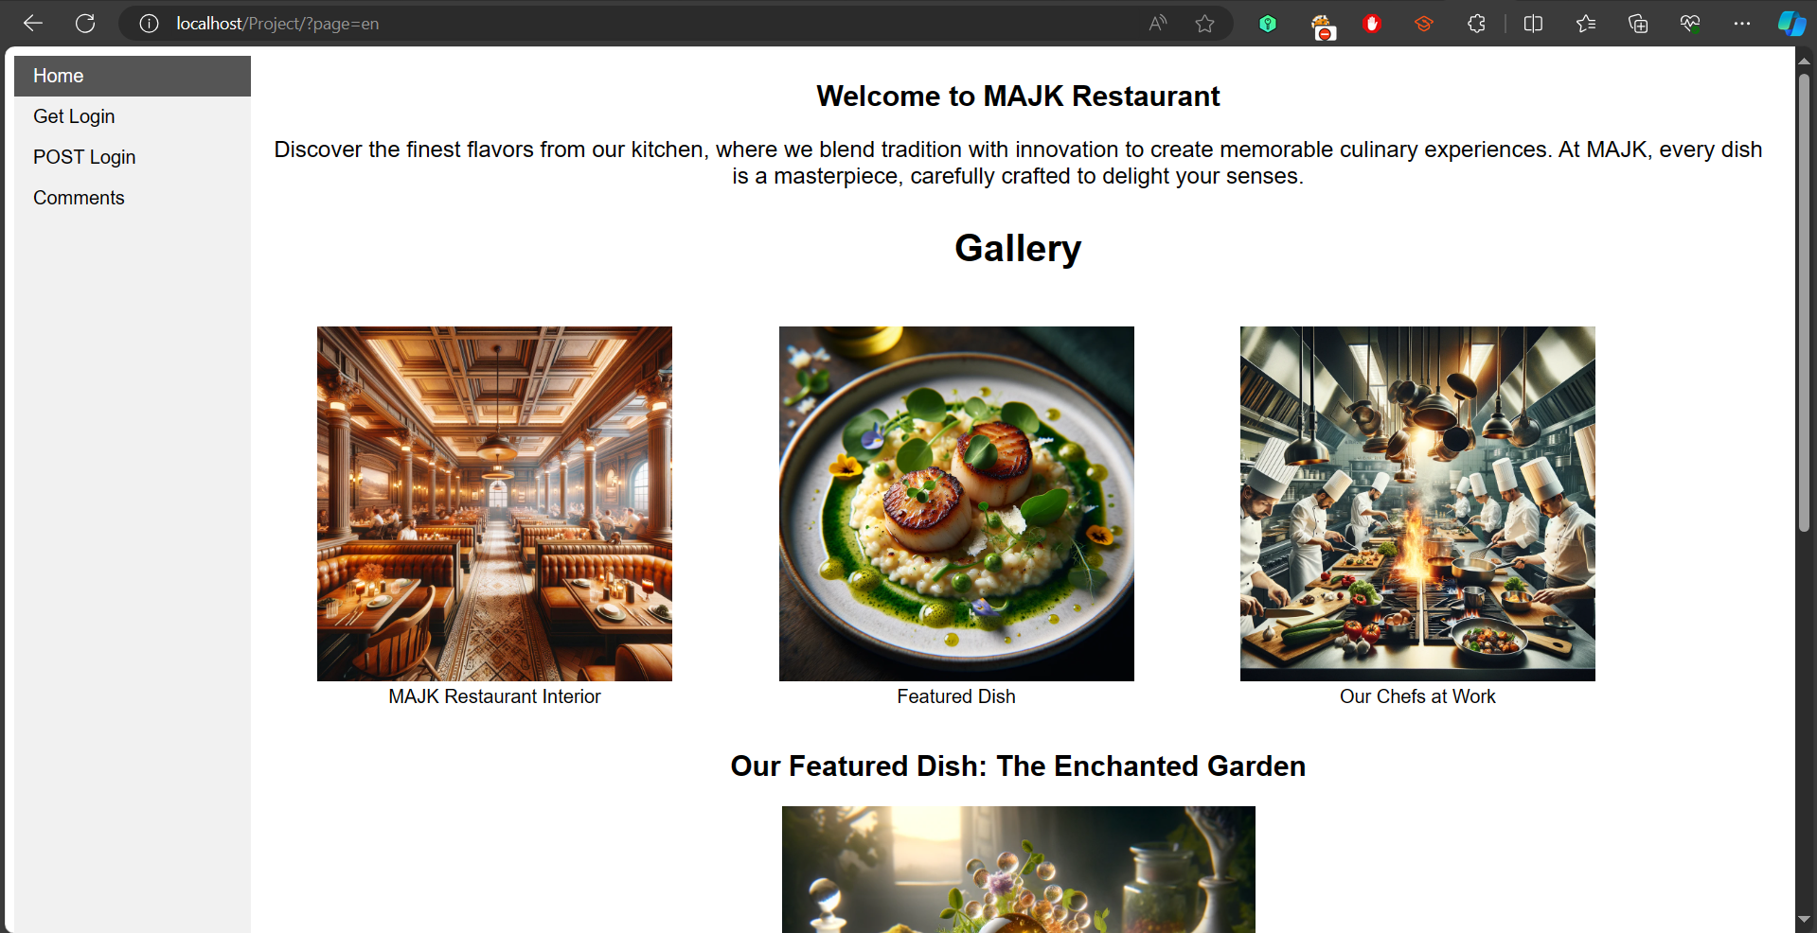

***Figure 1.*** MAJK website

The difference that this website had over the First website, is that we modified the GetLoginHandle.php to actually work with a database and verify the username and password of the users to simulate basic authentication. and some other modifications of the GetLogin.html in order for it to work with the vulnerabilities later on.

As shown in Figure 1. Now this webpage acts as a login handler, it accepts user credentials through the URL parameters (GET Method) and attempts to authenticate with a MySQL database. When the username and password are received from the login form, it will establish a database connection and execute a SQL query to verify the credential. if the authentication is successful then the user information is displayed which includes their Username, ID, and password. if credentials are wrong we would get a error message.

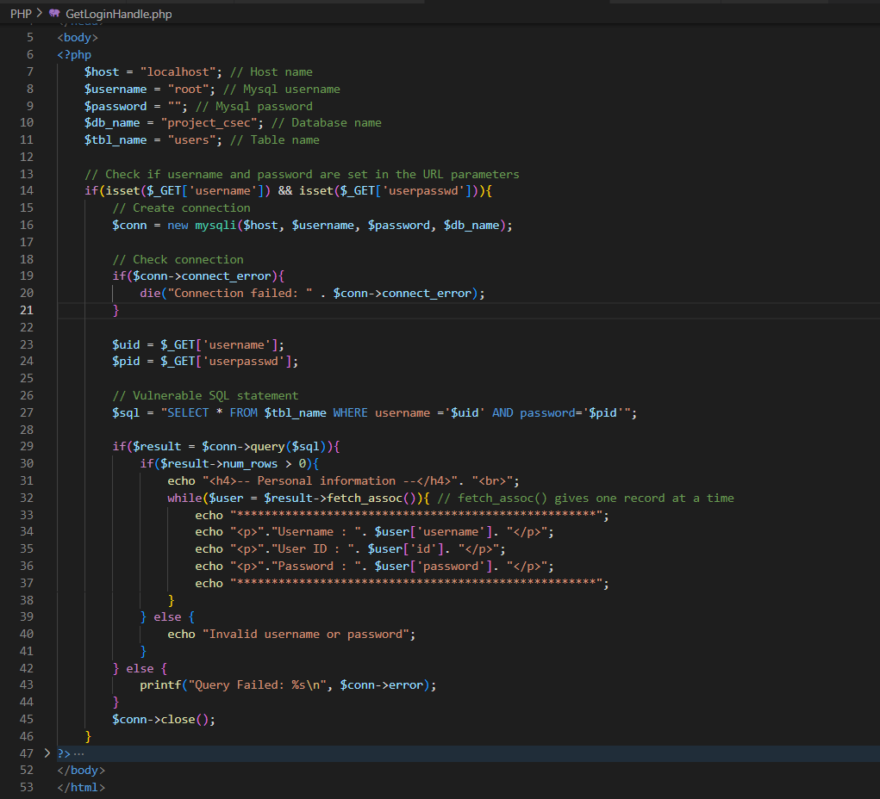

***Figure 2.*** The Modified GetLoginHandle.php

This modified GetLogin.html page is used by users to enter their username and password into the form, and in the modified form we added two buttons to submit the request to either a secure or insecure PHP script (used for SQL injection later on) these functions set the forms action to point to the corresponding PHP file.

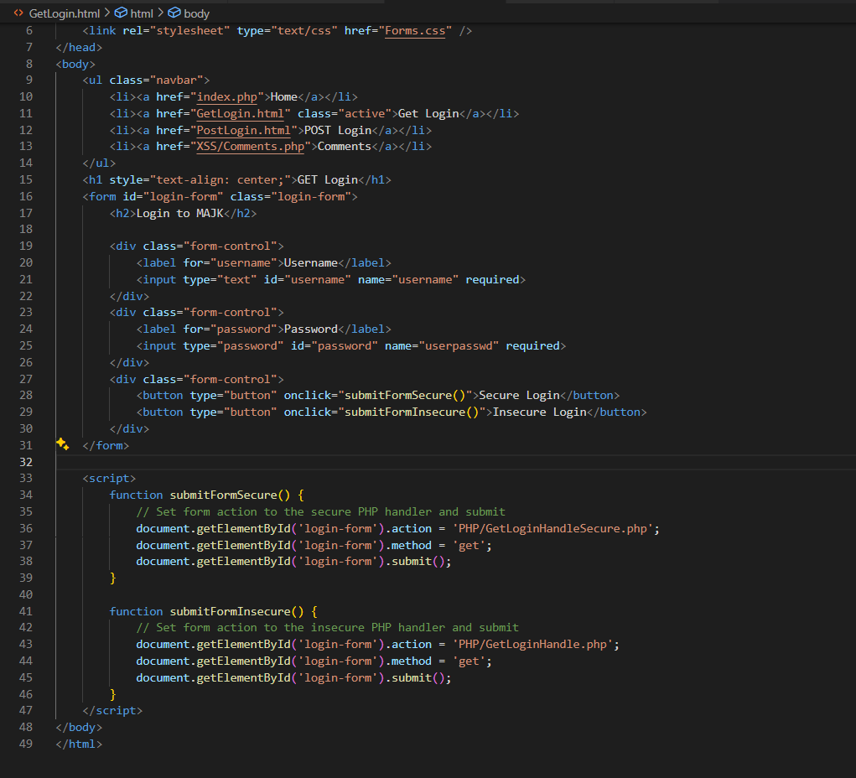

***Figure 3***. Modified GetLogin.html

We create the Comments.php page, it was made for guest reviews. it included a form where visitors can submit their name and a comment about the restaurant. submitted comments are posted to ‘submit-comment.php’ using a POST method. after that we have a PHP code which retrieves and displays all the comments from our MySQL database

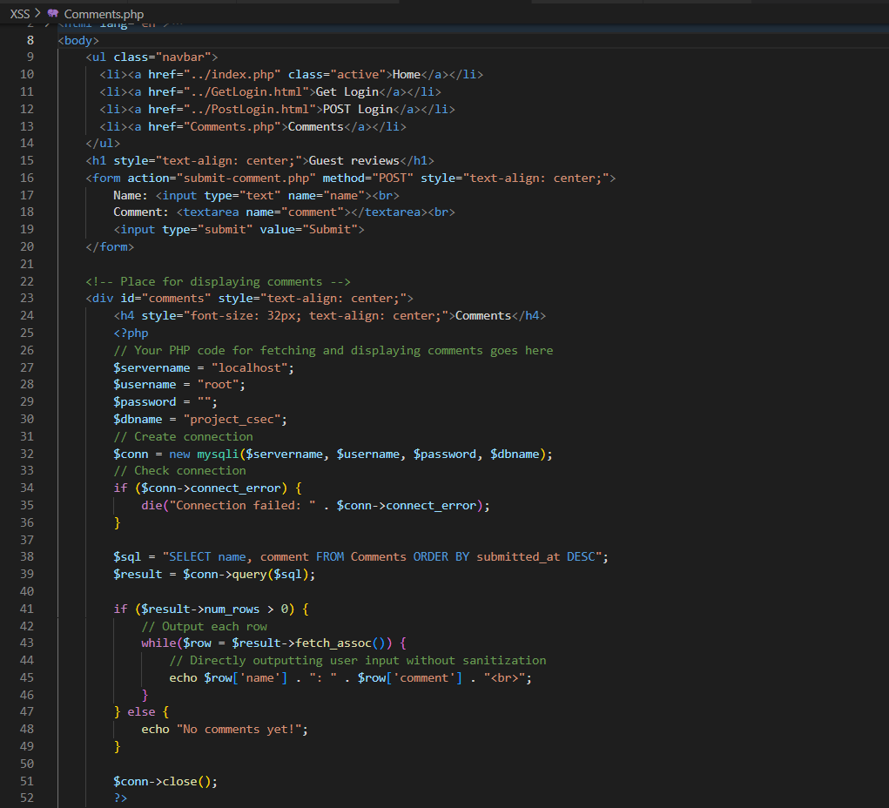

***Figure 4.*** Comments page

Figure 5 shows the importance of using Apache and SQL on the XAMPP program to access the vulnerable websites that we have created .

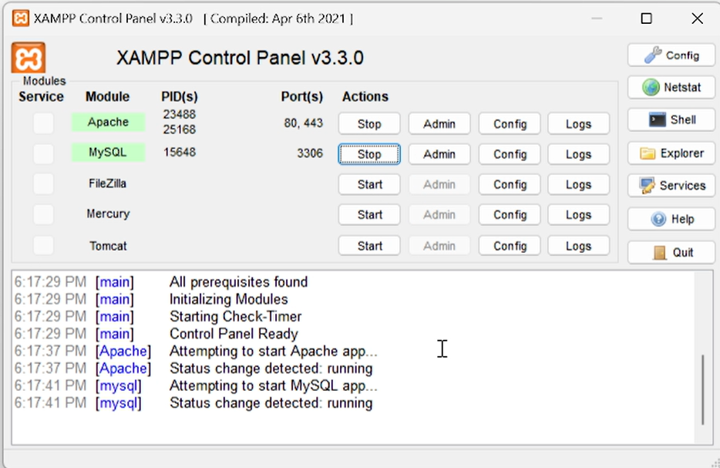

***Figure 5 .*** Starting MySQL and Apache on XAMPP

Figure 6 illustrates the process of creating a users table in the built website's Project_CSEC database in order to add users and their credentials to the website so they may login and access it.

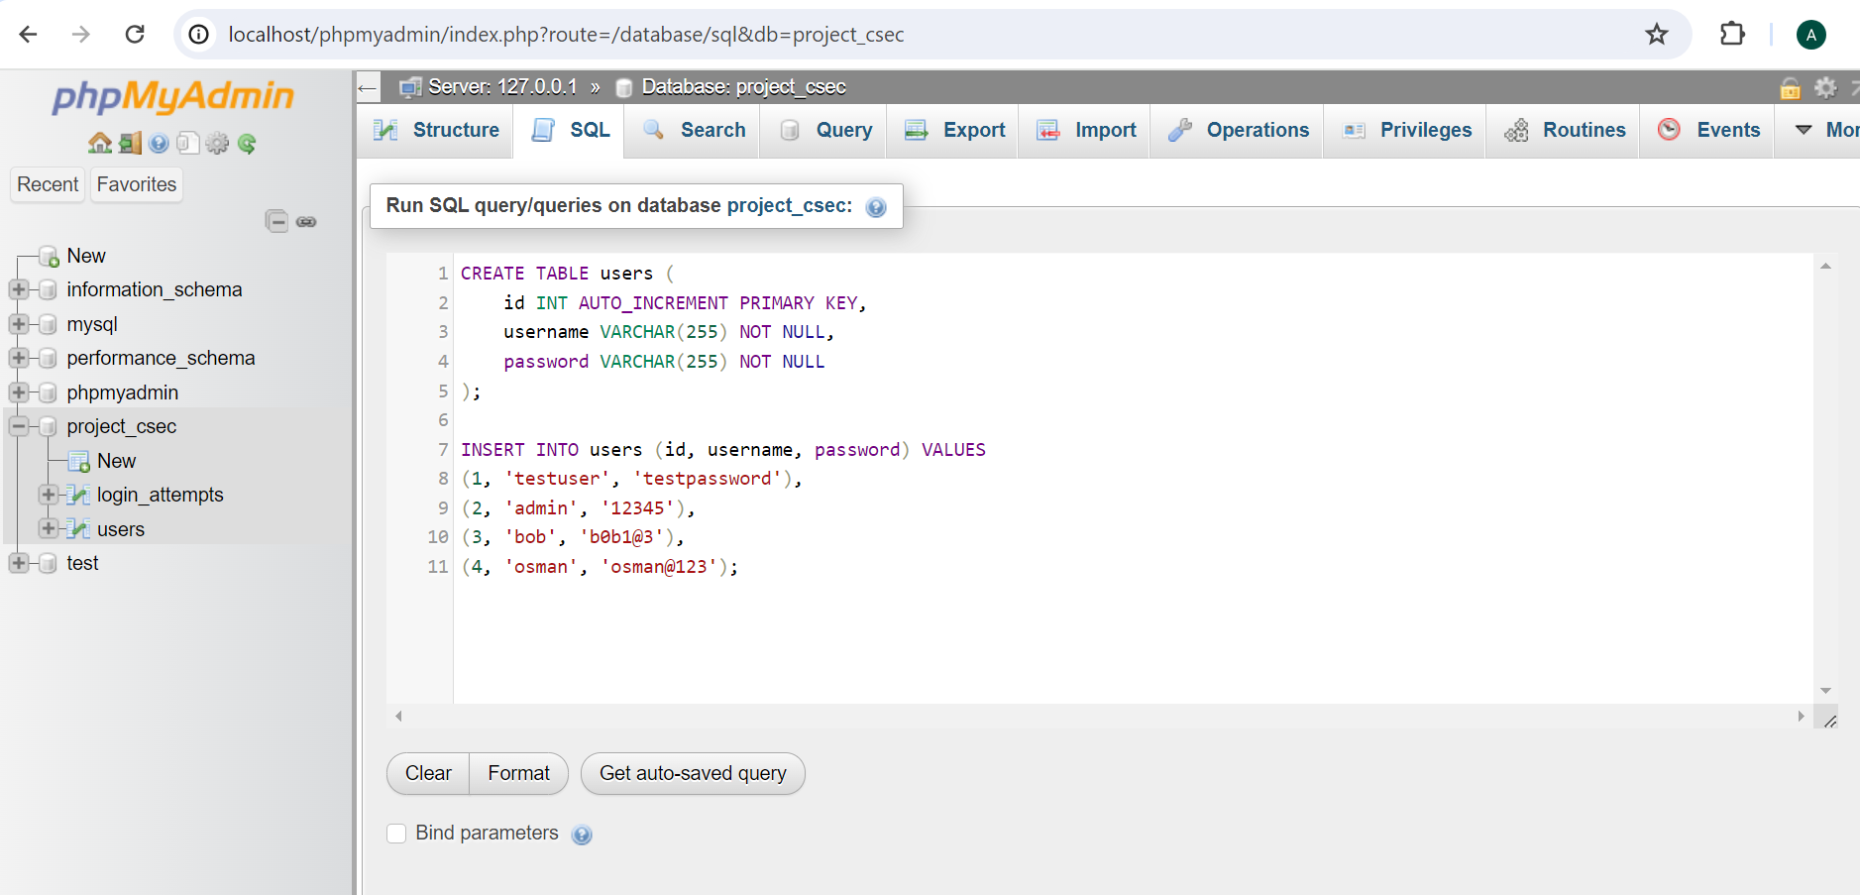

***Figure 6 .*** Creating Users Table on the Project_CSEC Database of the Website

# 5 Attacks

## Persistent XSS

First as an attacker he will have to find a page where he can inject his script and save it to the website in order to run his malicious script on the victim side.

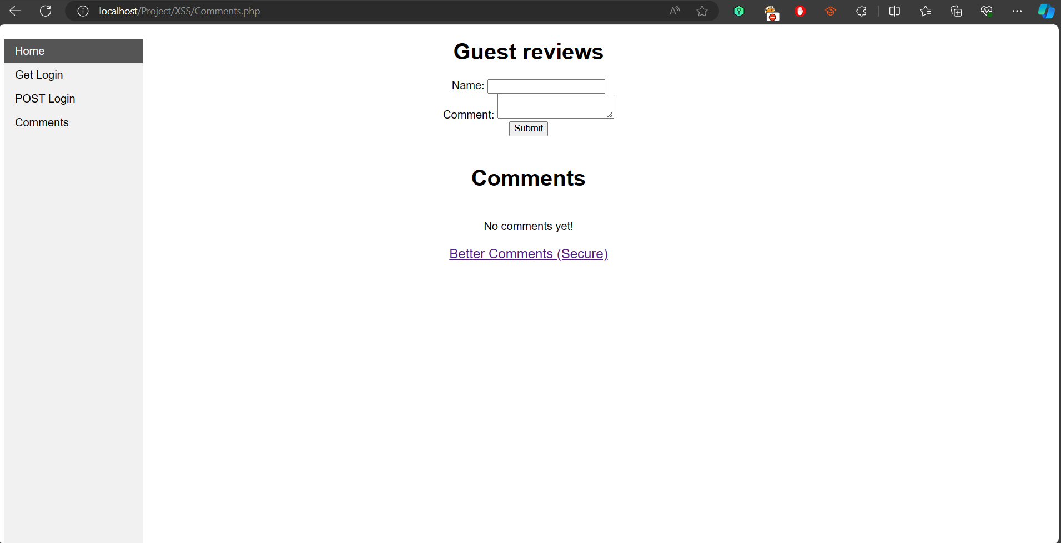

***Figure* 7*.*** Guest Reviews page

Then the attacker will write his embedded malicious script and submit it to the comments form and observe the behavior or the response of the website

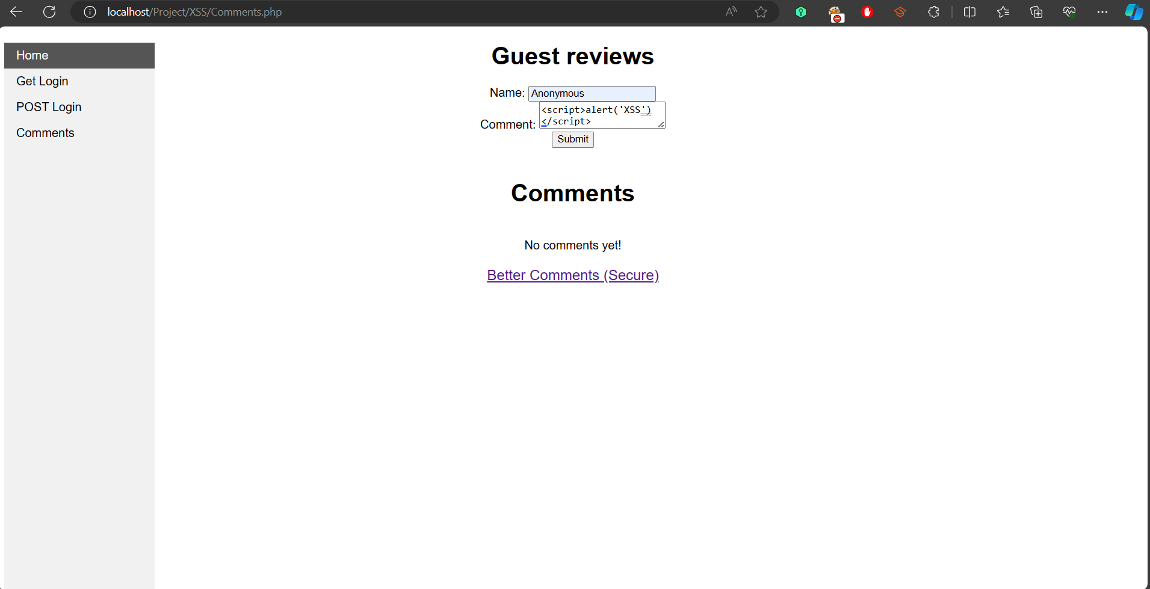

***Figure 8.*** Attacker wrote the malicious script

Here we can see that the attacker has successfully wrote the script and it was saved by the database.

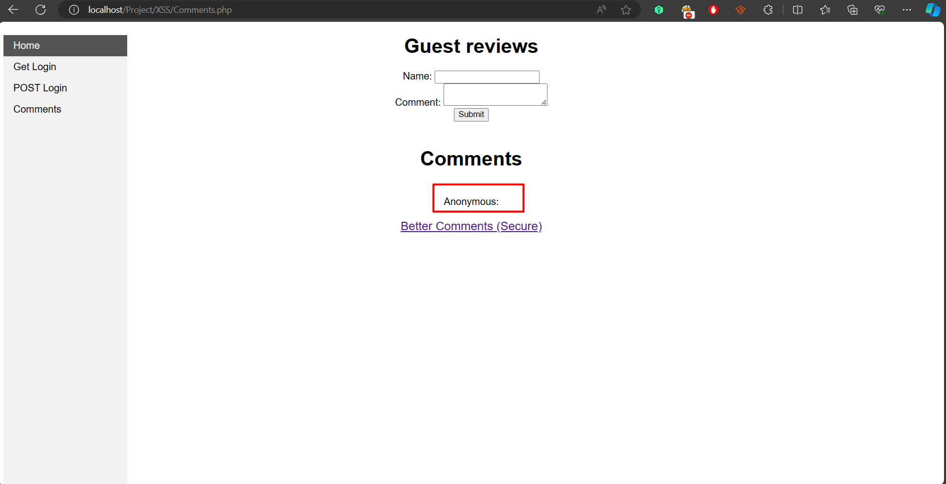

***Figure 9***. Attacker’s Script submitted

Now we will test if the script is affecting other users who are visiting the website, as we can see in Figure 10. Once the user has visited the Comments page, the victim's browser immediately executes the script that was injected by the attacker in the previous step.

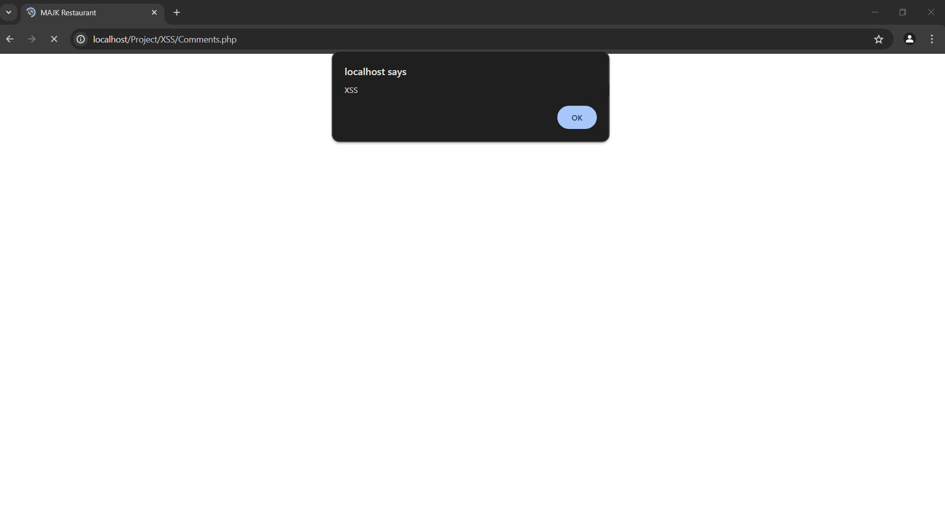

***Figure 10.*** The script running on the victim browser

## Simple SQL Injection Attack

First we will login normally to verify that the code and the database are working and giving the expected output.

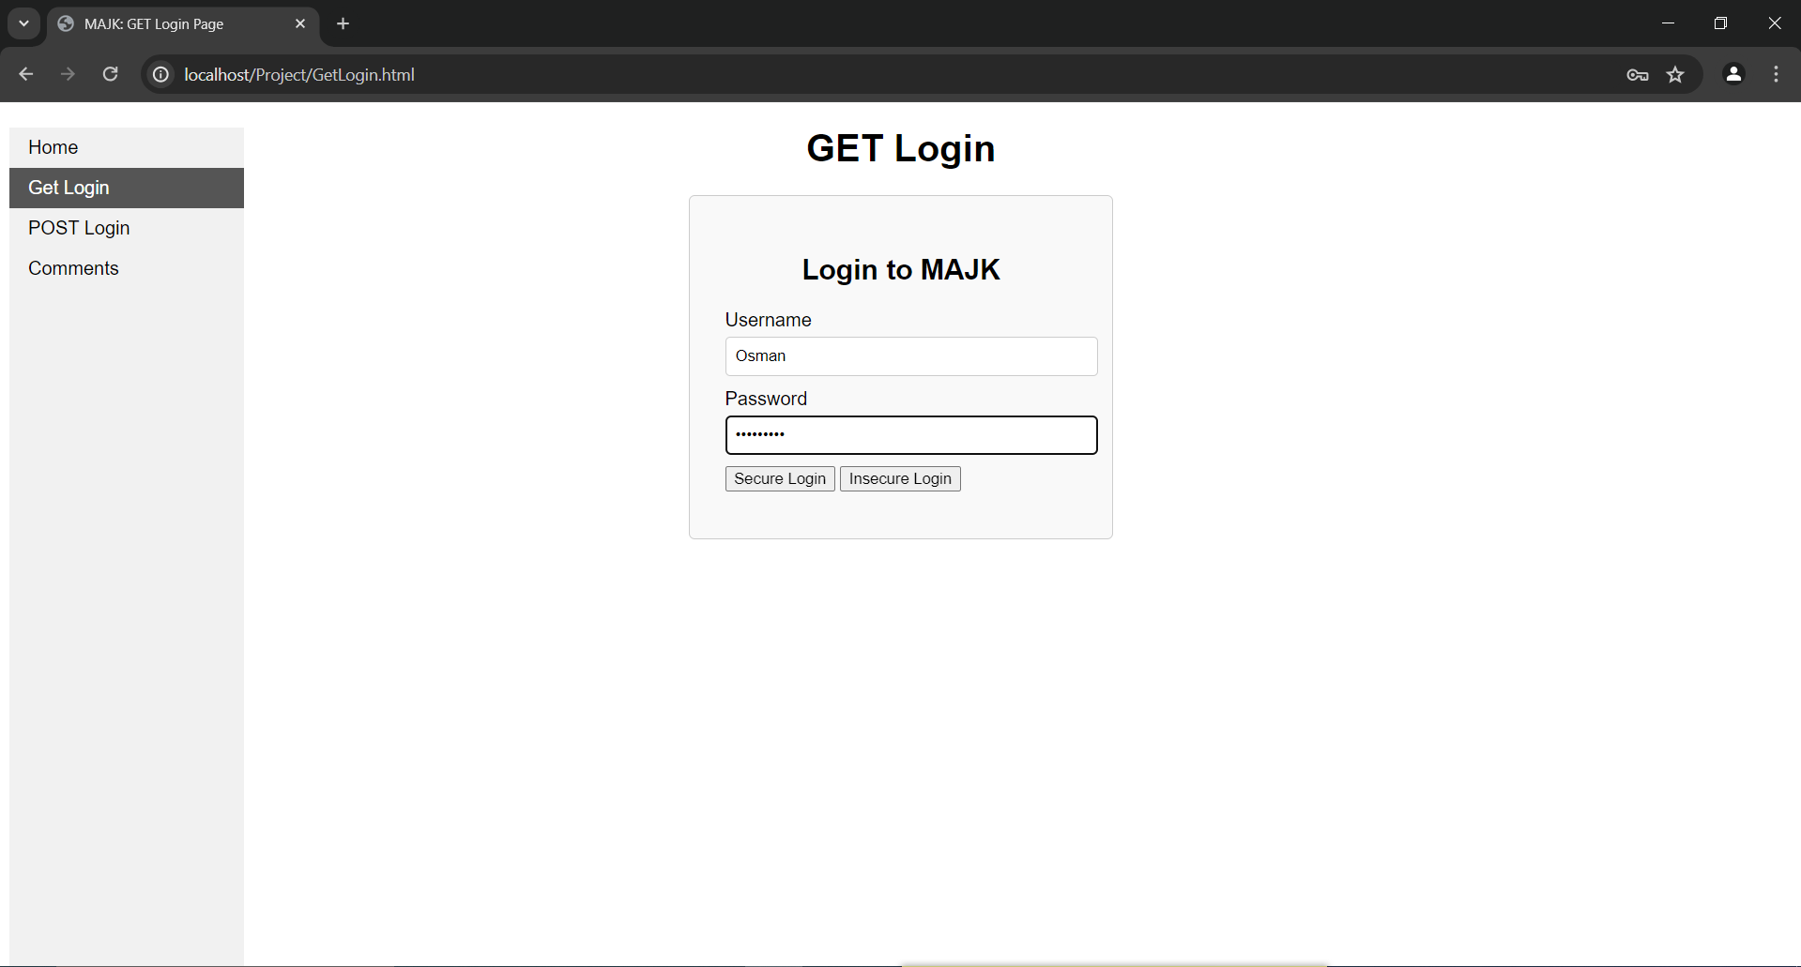

***Figure 11***. Testing the Login

We can see that the user logged in successfully and the information of the user is printed.

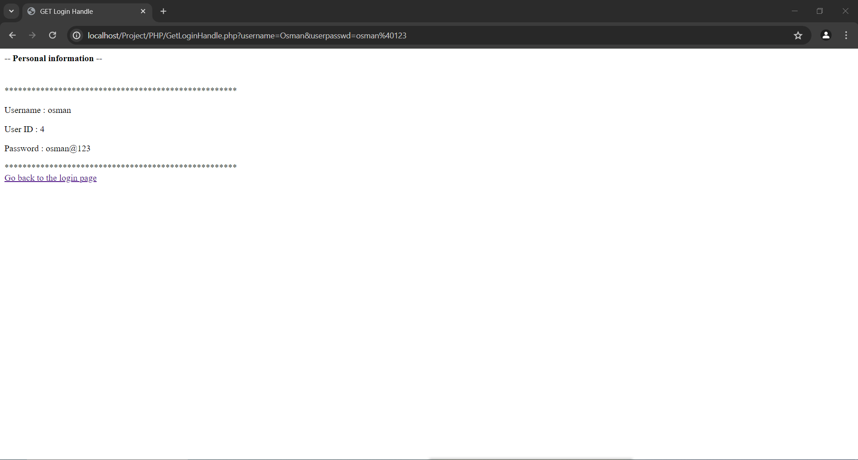

***Figure 12***. User successfully logged in

Now we will try an sql injection query to login the user, so we will put the username as “osman” and in the password field we will put this sql injection query ( anything' or '1'='1 ) and we will observe the response of the database.

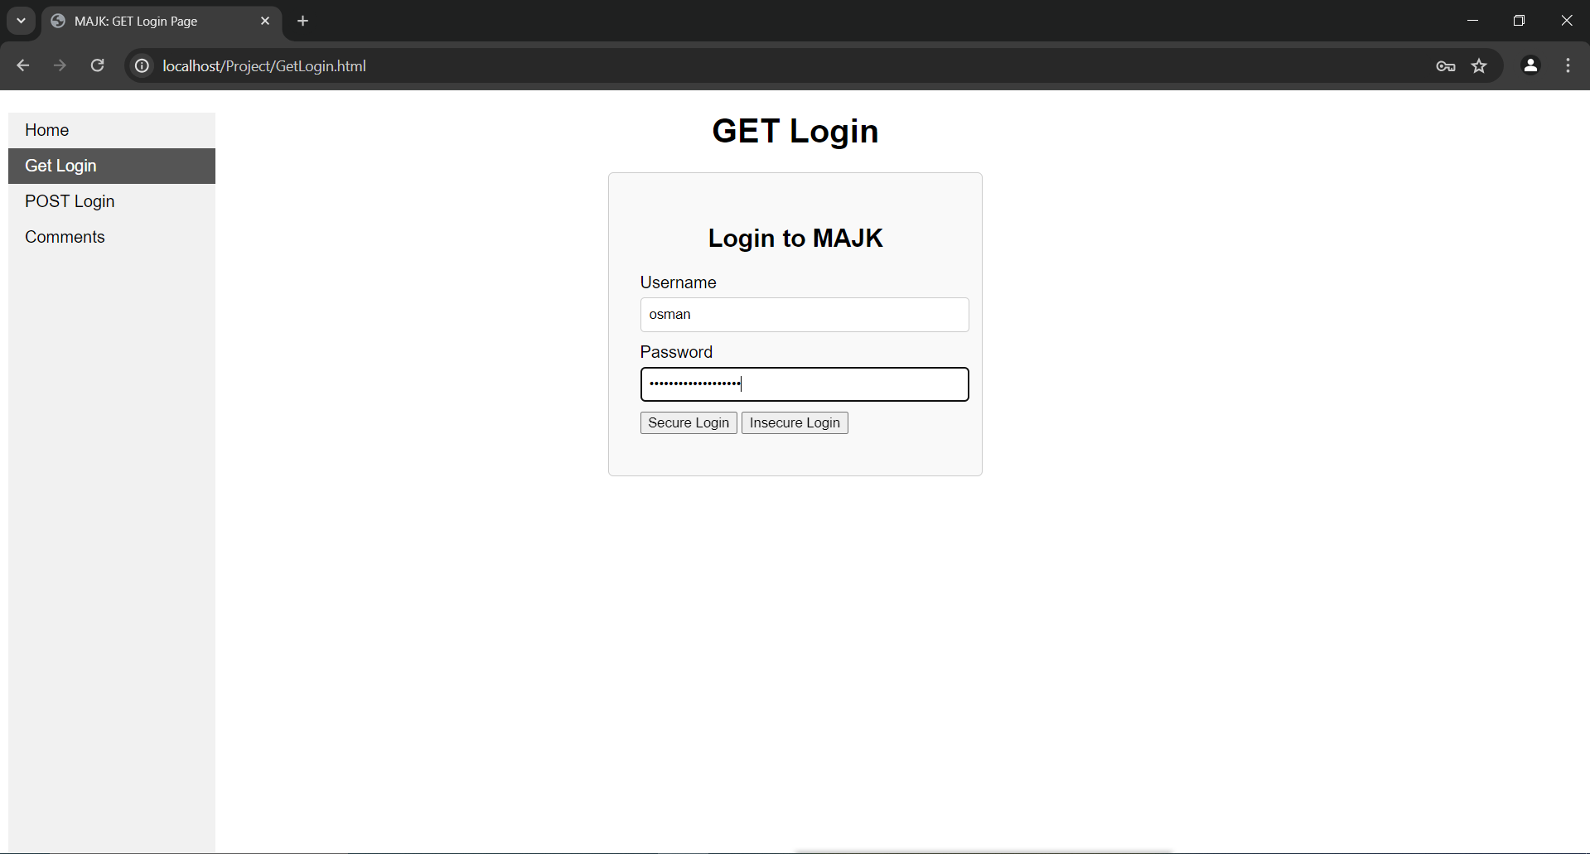

***Figure 13***. SQL injection query in the Password

After clicking on Login “insecure login” we can see that the database has leaked the database of the website, and now the attacker has unauthorized access to other users' information on the website. and this happened because of the lack of proper sanitization.

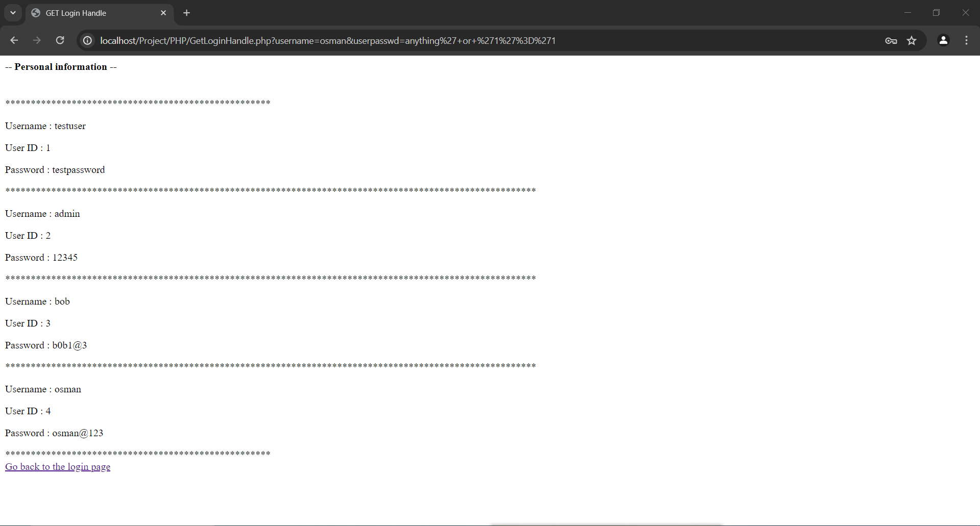

***Figure 14***. SQL Injection successful, database leaked

## LFI Attack

Here we will demonstrate the LFI attack, as we can see in the URL we have the parameter ( ?page=en ) which means that this website has a PHP script that is including other files on the website.

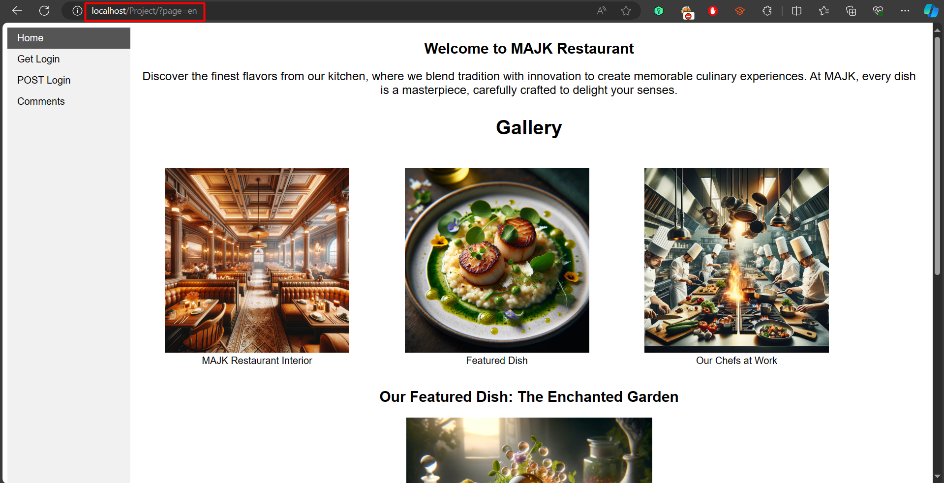

***Figure 15***. URL Inclusion parameter

Now we will try to traverse in the directories of the website by writing ( ../../ ) and we will observe the response of the website. As we can see in the website when we tried to traverse the directories backwards we received an error which means we are in the root directory of the website.

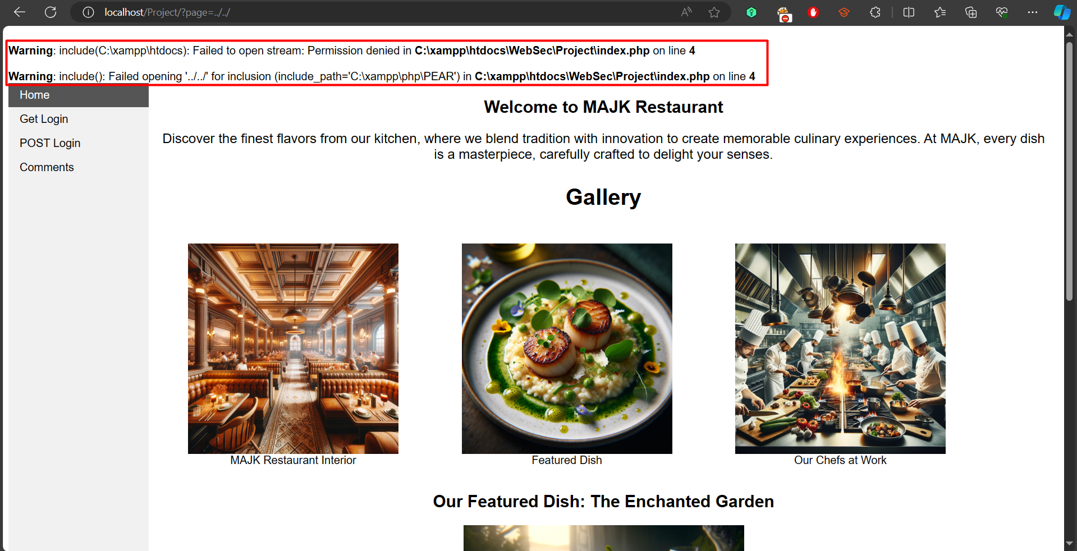

***Figure 16.*** Directories Traversal Error

Then we tried to look for known directories, so in the parameter we entered ( ?page=etc/password.txt ) and that was successful and we have the contents of the password.txt file printed on the website.

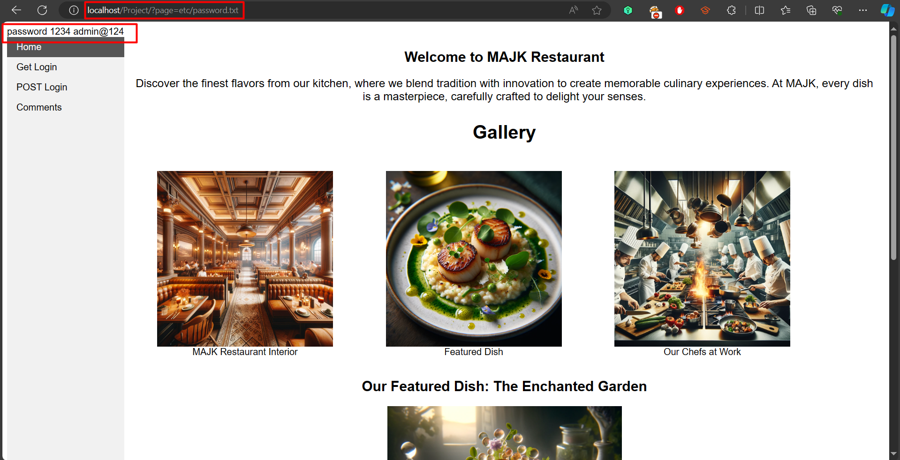

***Figure 17.*** Password file included

## Brute-force attack

In this section, we will go over each step in detail, from creating a brute force attack script using Javascript to carrying out the brute force attack on the website. A brute force attack is a hacking method that gains illegal access to user accounts and company systems by using trial and error to crack passwords, login credentials, and encryption keys (Tam, 2023).

Figure 18 demonstrates that before we can begin performing the brute force attack on the previously built website, we must first start Apache and SQL on XAMPP so that we can access it.



***Figure 18* .** Starting MySQL and Apache on XAMPP

Figures 19 and 20 show a brute force attack script that we created in JavaScript to deploy a brute force attack approach to breach a login system by repeatedly trying to log in using predefined password lists. The brute force attack begins by determining whether a username has been entered and if not, it stops with an error message and starts attempting passwords one at a time using the "tryPassword" function. In order to send a request to the login endpoint, it creates a URL using the username and the current password for each password attempt. The system logs the credentials if the reply shows a successful login and if not, it records a failed attempt and goes on to the next password until all passwords have been used.

**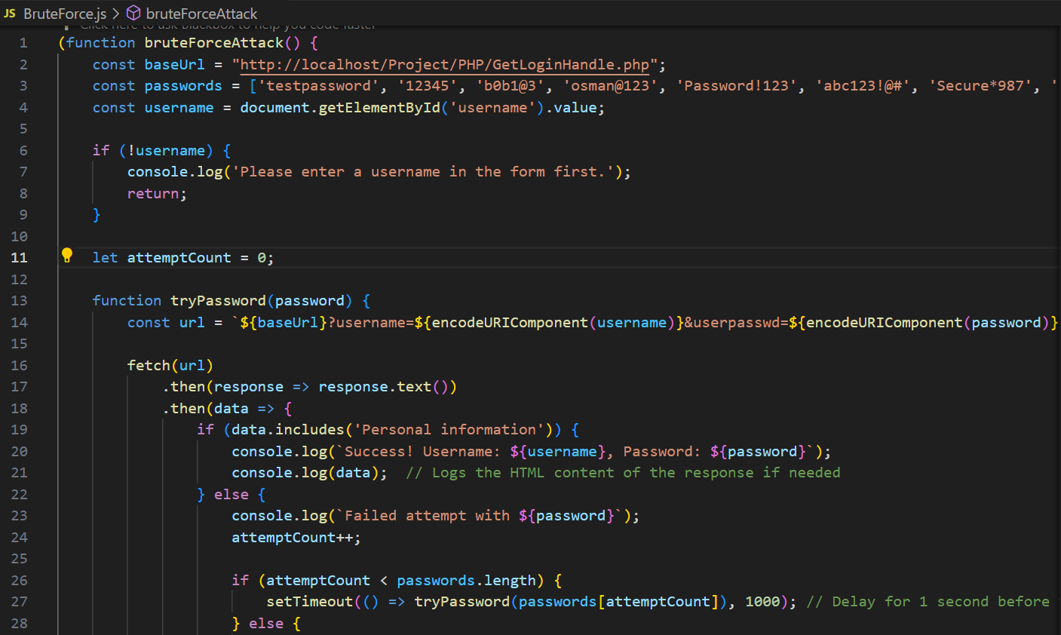*Figure 19.*** Brute Force Attack Script Using JavaScript

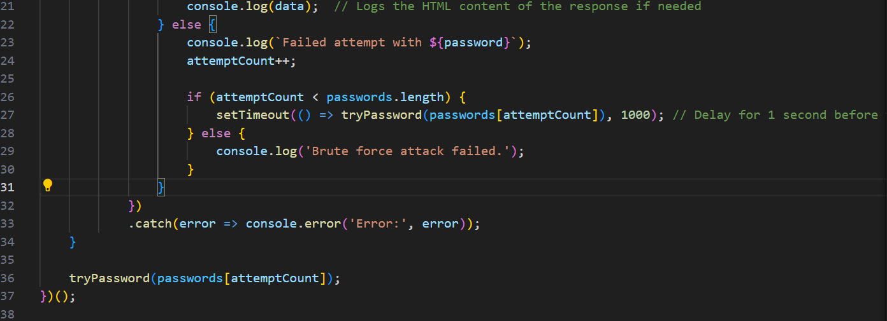

***Figure 20.*** Continuation of theBrute Force Attack Script Using JavaScript

Figure 21 illustrates how we will begin the brute force attack by first visiting the GET login page website and right-clicking on "Inspect" before selecting the console tab. Then we're going to copy and paste the previously constructed brute force script into the console tab. Before running the script, we must enter the username on the GET login page. Assume that we already know the username "osman" and type it. The script will then be executed by pressing the enter key on the keyboard, and we will wait until it discovers a password that matches the username we inputted.

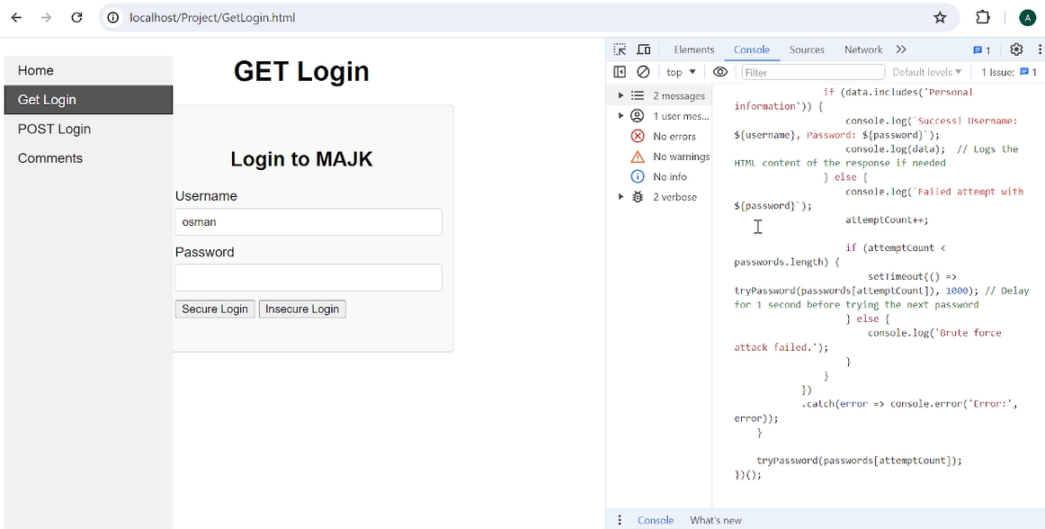

***Figure 21 .*** Running the Brute Force Script in the Console Tab of the GET Login Page

Figures 22 and 23 indicate that the brute force attack was successful, as it discovered the password for the username "osman," which is "osman@123." It also gave personal information for the user, "osman.". The attacker retrieved the password and input it into the GET login page, which allowed the attacker to gain unauthorized access to the profile of the account "osman." This proves that the website is vulnerable to brute-force attacks.

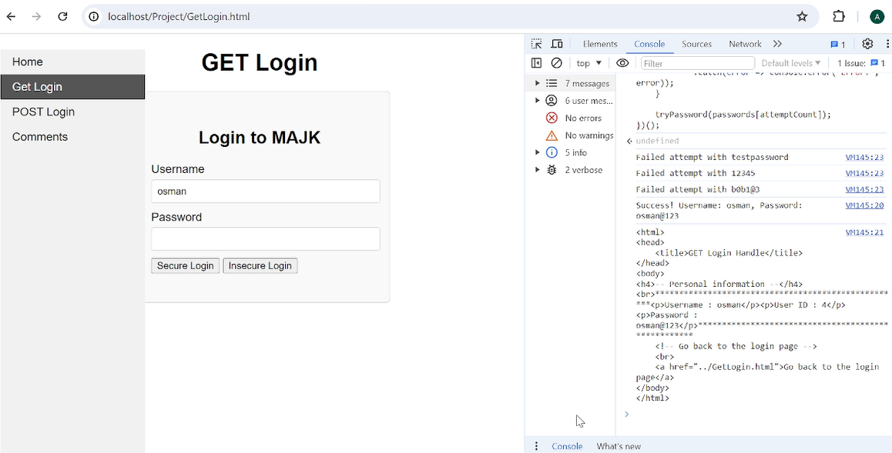

***Figure 22 .*** Successful Brute Force Attack on the GET Login Webpage

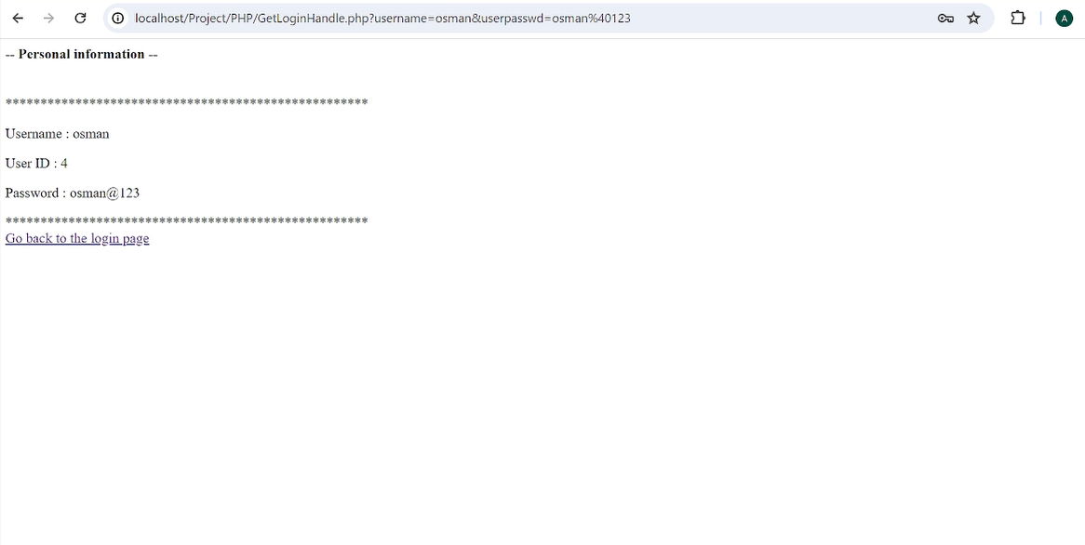

***Figure 23 .*** Unauthorized Access to the Profile Page of the "osman" Username Using Brute Force Attack

## Insecure Direct Object References (IDOR)

In this section, we will explain how to perform the insecure Direct Object References (IDOR) attack. IDOR attacks happen when a website gives access to objects based on user input. Through IDOR, attackers can bypass authorization and gain direct access to resources like files or database records of other users by changing parameters assigned to point to an object. This attack takes place when a website collects data from its users and retrieves an object without conducting sufficient authorization checks (OWASP Foundation, 2024).

We will start by modifying the code to make the website vulnerable to IDOR attacks.

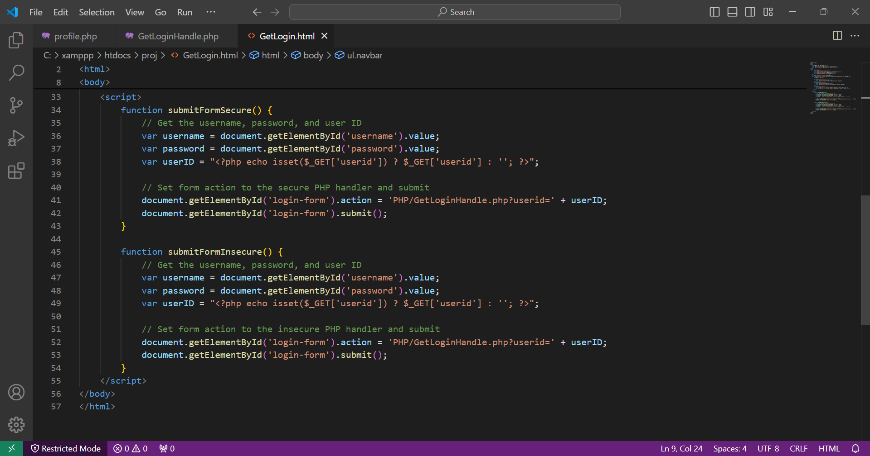

***Figure 24.***  Part of GetLogin.html code

As shown in figure 24 above, in the GetLogin.html file, we added this code, where there are two functions ‘submitFormSecure’ and ‘submitFormInsecure’ that get the username and password as inputs from the user, as well as the user ID from the URL parameter ‘userid; by referring to the PHP code.

After that they set the action attribute of the login form to a PHP handler script (PHP/GetLoginHandle.php), which includes the userid parameter in the URL.

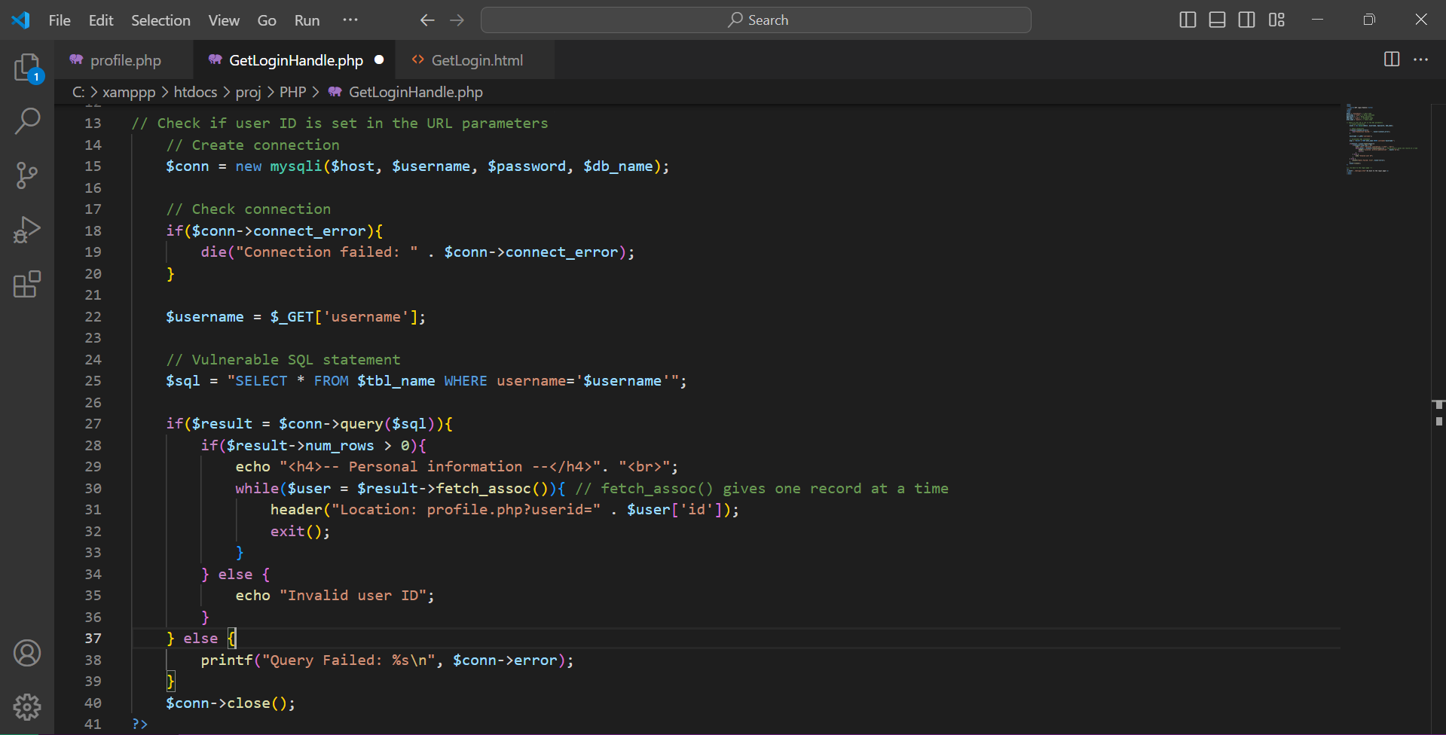

***Figure 25.***  Part of GetLoginHandle.php code

In the GetLoginHandle.php file, we added the code shown above in figure 25. This part of the code connects to the MySQL database to enable the interaction with the database to get users information. This would allow the attacker to easily login and change the ID to gain unauthorized access to other users personal information.

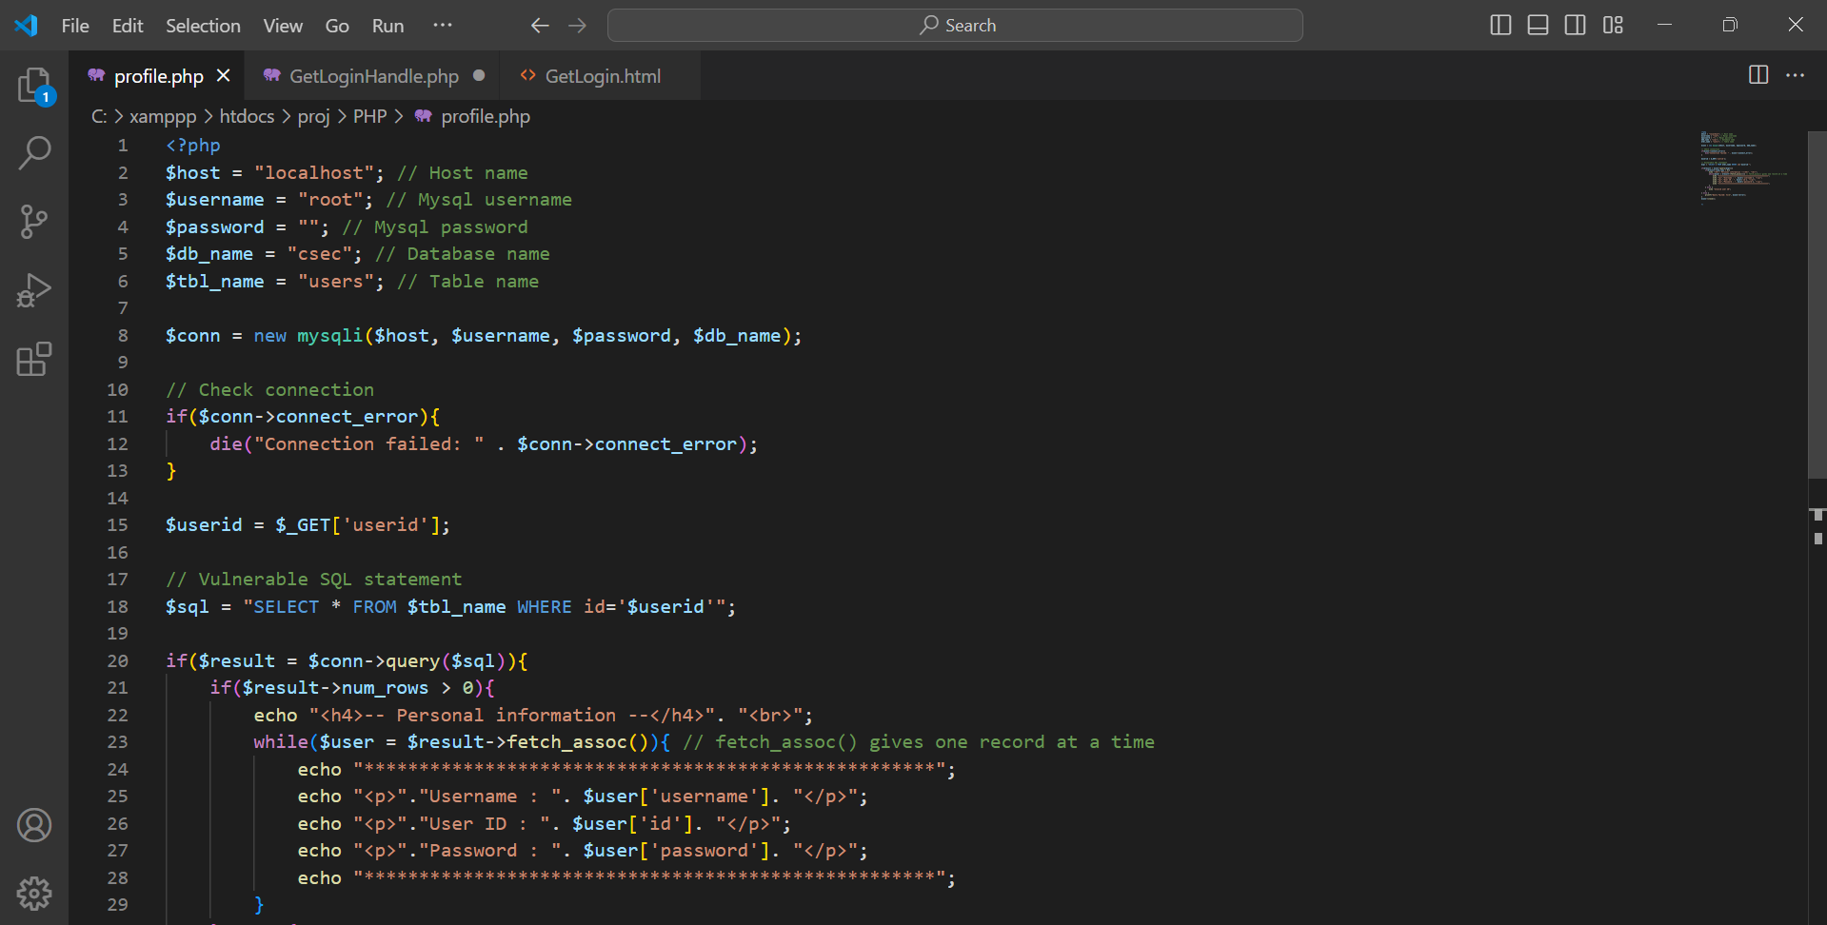

***Figure 26.***  Part of profile.php code

In the profile.php file, we added the code shown above in figure 26. This part of the code uses $_GET['userid'] to obtain the userid parameter from the URL without performing the required authorization or validation checks, which enables attackers to manipulate the URL and change the userid to access other users personal information thereby exploiting the IDOR vulnerability.

After modifying the code, we created a database called “project_csec” and added a table called “users” that includes the user's ID, username, and password, as shown in Figure 27 below.

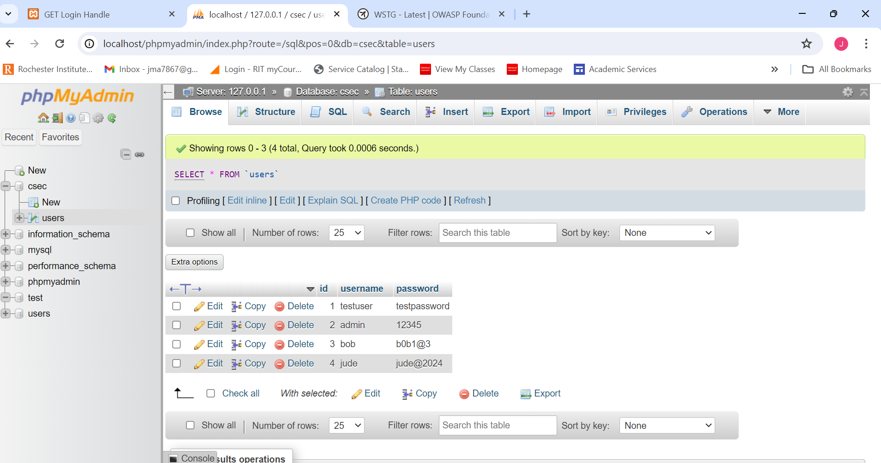

***Figure 27.***  Csec database and users table

Now, to test and perform the IDOR attack, we should first open the login page of our vulnerable website and enter valid credentials to login. For example, as shown in figure 28 below, we used bob as the username, and b0b1@3 as the password.

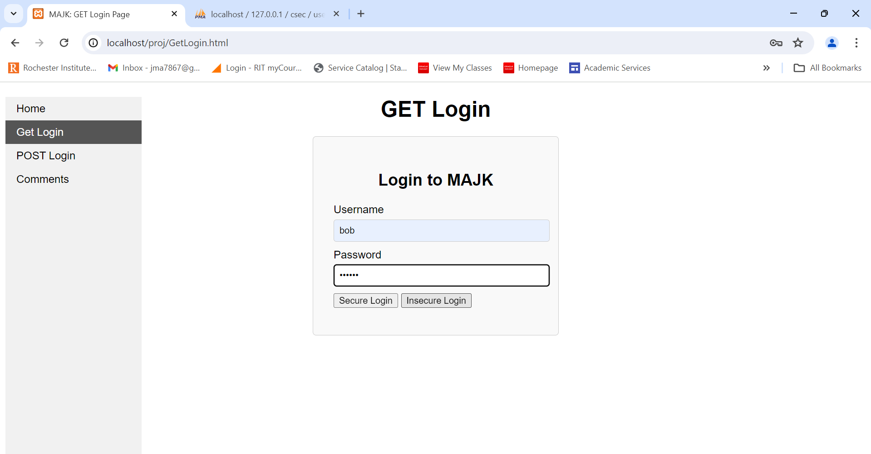

***Figure 28.***  Login page

After a successful login, as shown in figure 29 below, the user will be able to see a page that displays personal information, including their username, password, and user ID, and they can observe their personal information in the URL.

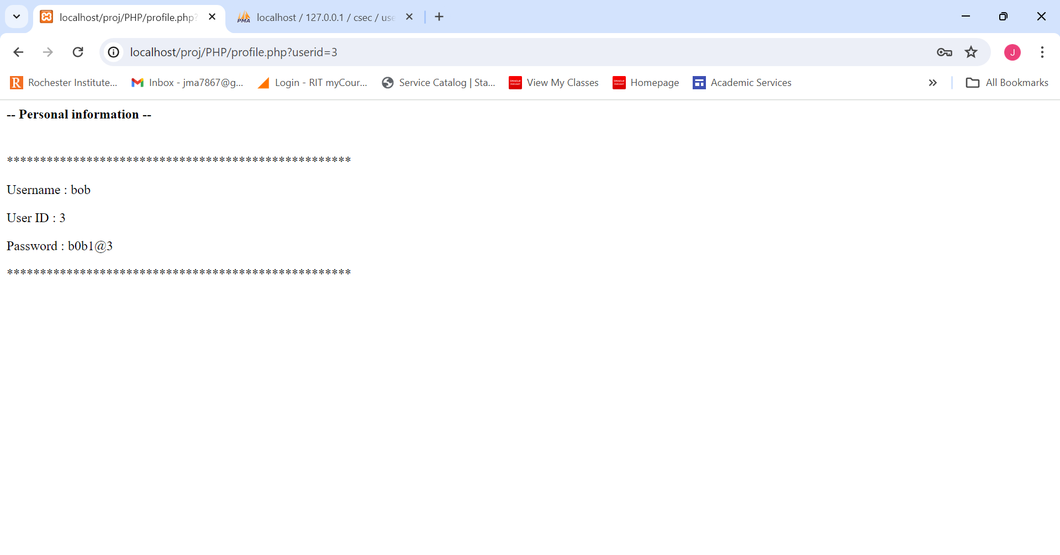

***Figure 29.***  Personal information page

Since we can clearly observe the personal information in the URL, this enables the attacker to simply manipulate and change the ‘userid’ parameter in the URL to any other user ID. By reloading the page with the modified URL, the attacker will be able to gain access to and view other users personal information without proper authorization. And this is because the value of the user ID parameter in the URL is used as an index in the users table in the database. Taking this parameter's value, the website uses it in a query to the database, and the user's information is then retrieved and returned to the attacker.

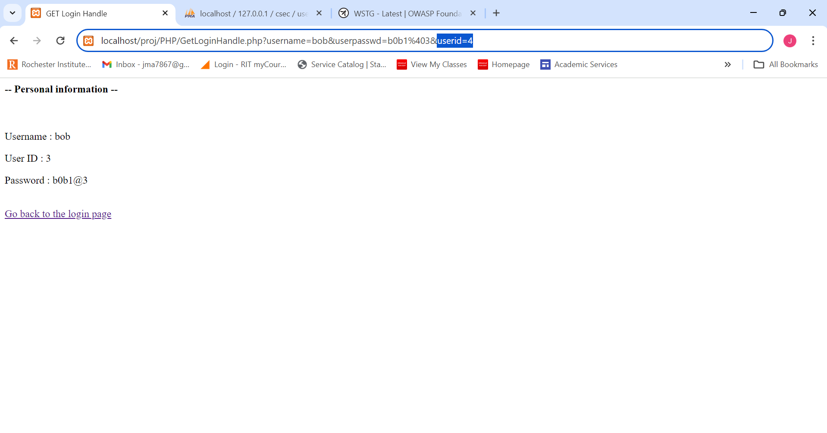

***Figure 30.***  Changing userid in the URL

For example, as shown in figure 6 above, we easily changed the user ID to 4 and got access to Jude’s personal information, as shown below.

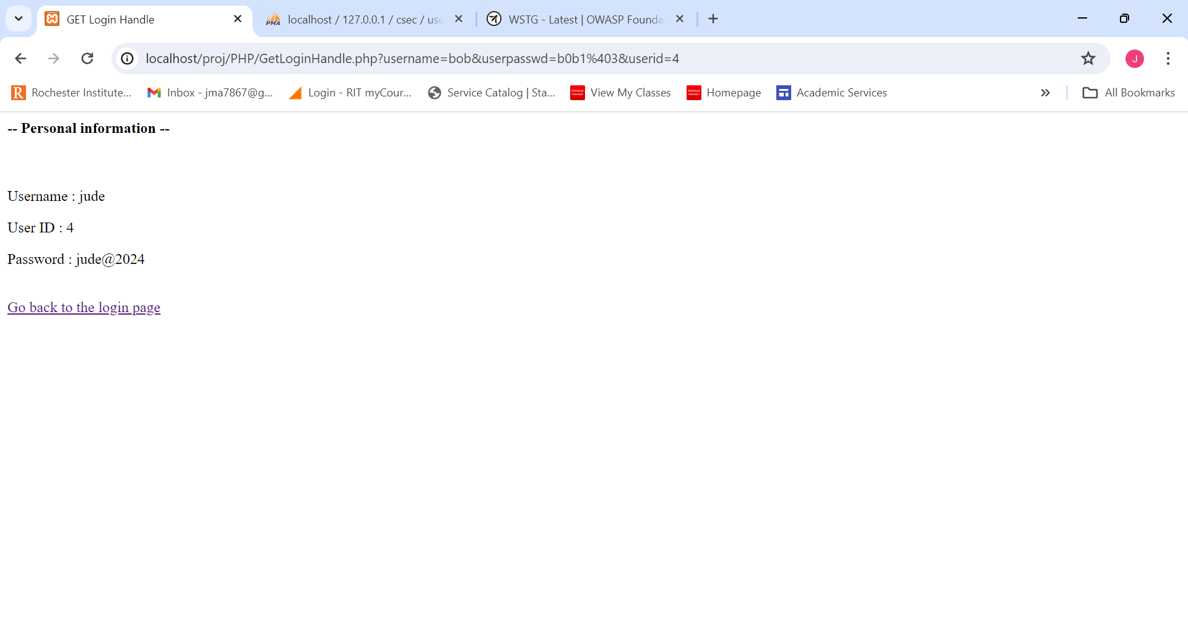

***Figure 31.***  Personal information page of other users

By following these steps, attackers can exploit this vulnerability and enable them to bypass authorization, to get direct access to system resources, like files or records in the database, and steal personal information from other users without proper authorization.

# Vulnerabilities and Mitigations for Each Attack

## Persistent XSS

Persistent Cross-Site Scripting (XSS) happens when the user provided data is stored on the webserver database, and then it's displayed to the other users which are the victims and this data is usually not properly sanitized. This allows the attacker to inject malicious scripts into trusted webpages that are usually viewed by other users the impact varies depending on the scripts injected but it can lead to: Stealing of the cookies or session tokens, Redirecting the user to malicious websites using Javascript, and unauthorized actions on behalf of the user.

for the attacker to be able to exploit that he should, for example, submit a comment that contains a script tag embedded (e.g, <script>alert(‘XSS’)</script>). if this input is not properly sanitized before it begins to be stored and displayed on the website, this script will execute in the browser of every user who views the comments page, potentially leading to a security breach.

Here is the code snippet of our code that handles the comments, and it's insecure because the code directly outputs the inputs given by the user which are the name and comment without sanitizing them, which makes this code vulnerable to XSS.

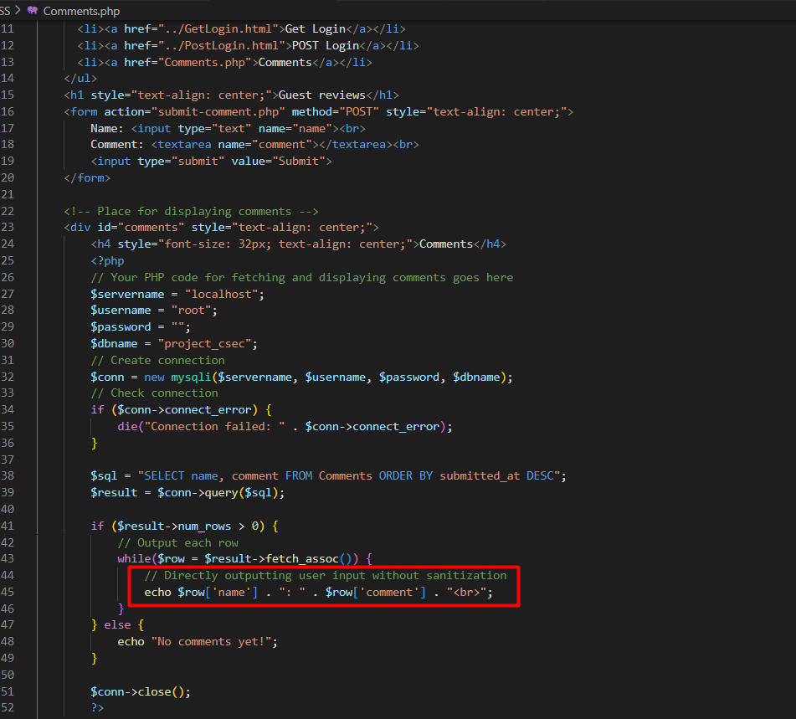

***Figure 32***. The insecure (Vulnerable) code of Comments

Now we will demonstrate the secure version of the comments, since we are using the same database to store comments we don't need to go through the whole process of injecting the script, so we will just visit the secure page from the victim browser.

As we can see in Figure 33. when the victim loaded the secure version of the comments the script was not executed on the browser of the victim. and that's because the code sanitized the user displayed and entered by the users.

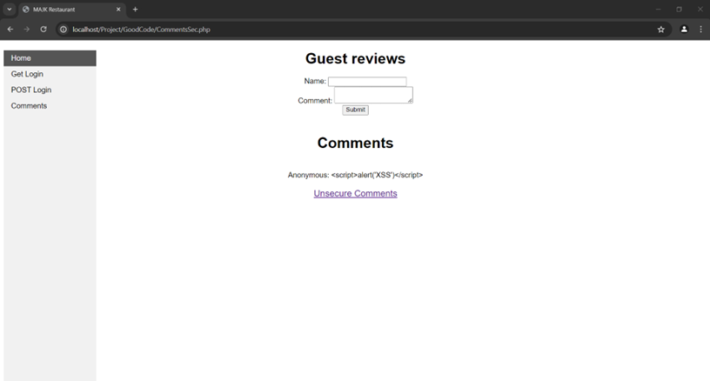

***Figure 33.*** Victim Visiting the secure comments version

Here we modified the code that displays the comments on the website, in this modification we used the function htmlspecialchars to escape special HTML characters from the user input before displaying them on the page, which will effectively be able to mitigate the XSS since its preventing the browser from executing the input as a code.

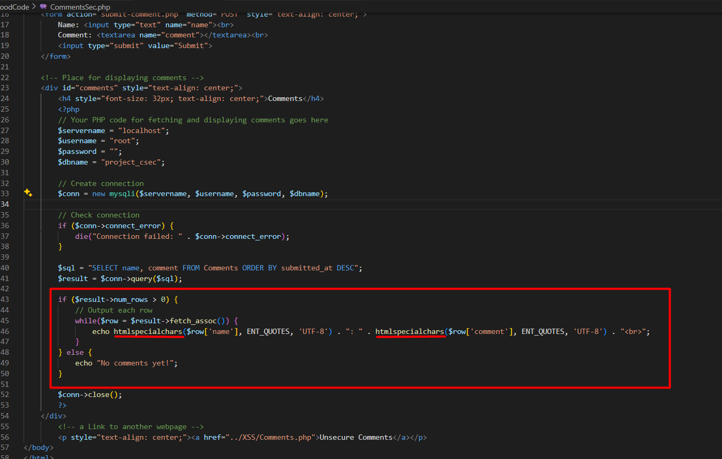

***Figure 34*.** Secure version of the comments page

## SQL Injection

SQL injection is an attack that happens when an attacker tries to manipulate a SQL query by inserting or altering SQL command using the user input this is not properly sanitized before its sent and executed in the database of the website, this attack can allow for unauthorized database manipulation and access of data.

The attacker can exploit this vulnerability by inserting SQL command into inputs that are directly used in SQL queries by the website. For example, inputting (admin' –) in a username field could manipulate the SQL to bypass authentication checks if the input is not properly sanitized.

as we can see in Fig 35. is the vulnerable code that we have developed for SQL injection, in this PHP code here the user inputs which are the username and password are directly included in the SQL query without any checks or safeguards, so this practice exposes the website directly to SQL injection attacks.

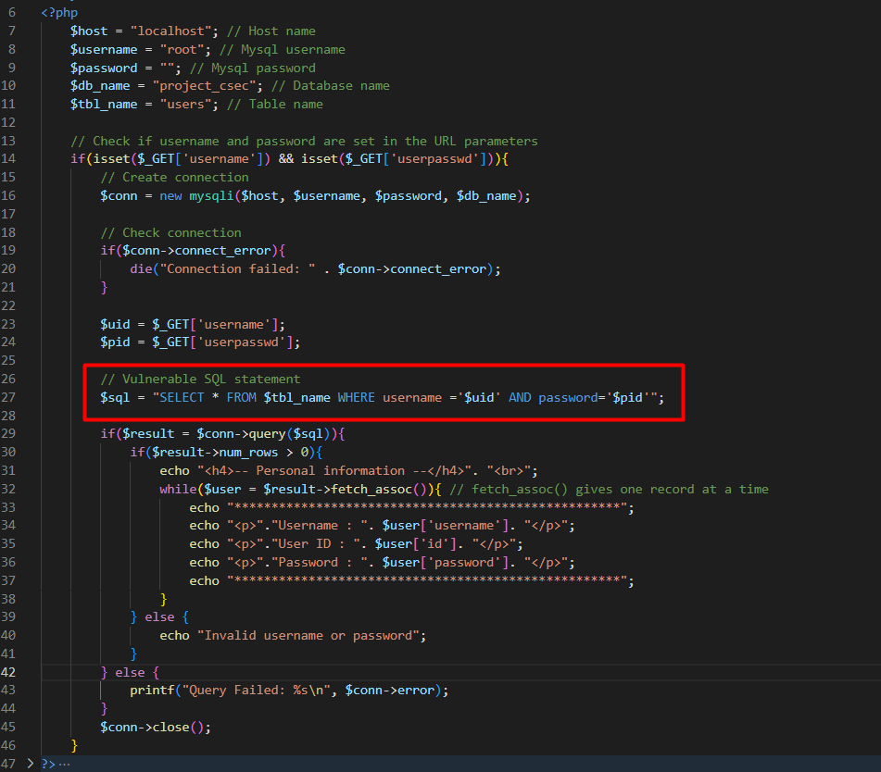

***Figure 35.***  SQL injection vulnerable code

Now we will demonstrate the secure version of the Login handling page to demonstrate if the secure version will be able to handle the query properly. will do the same steps again will input the username as “osman” and the password field would have the SQL injection ( anything' or '1'='1 ).

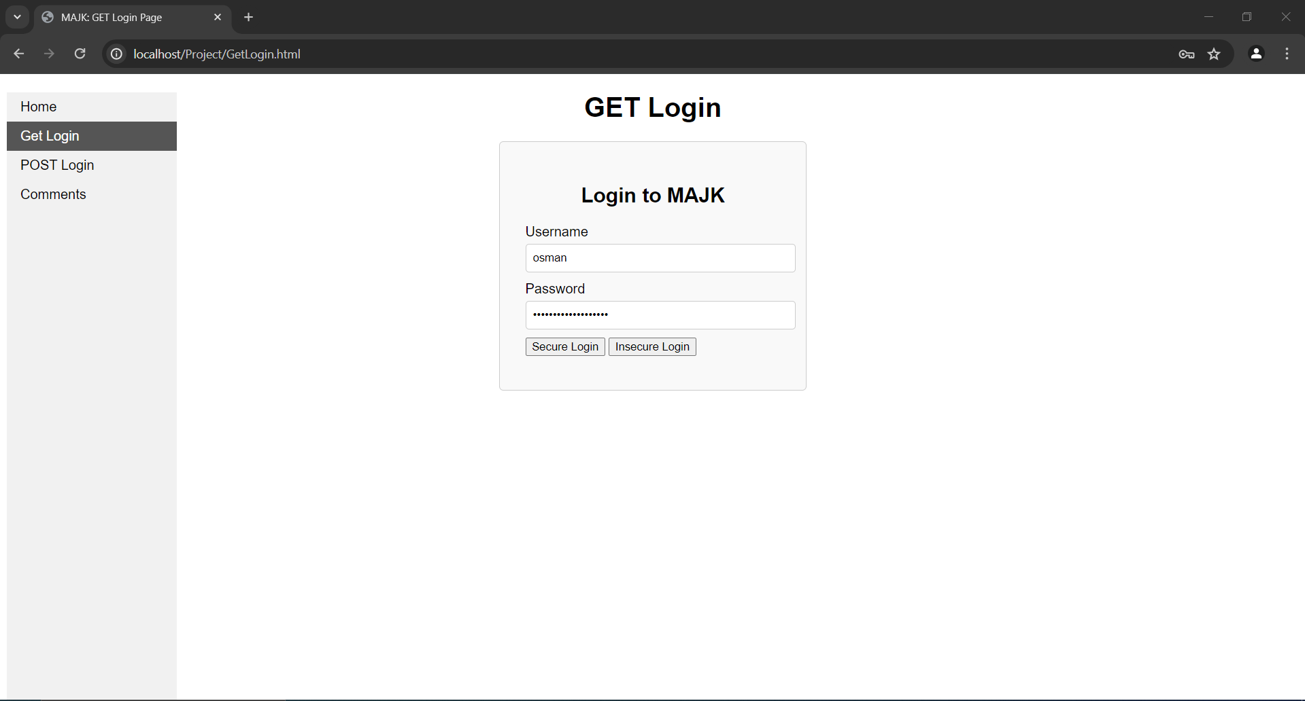

***Figure 36.*** SQL injection query in the Password

After clicking on the “Secure Login” the website gives the attacker an error saying invalid username or password not specifying which one of them was wrong which is a good thing, and the attack didn't work because the modified code had proper handling of the input given by the user.

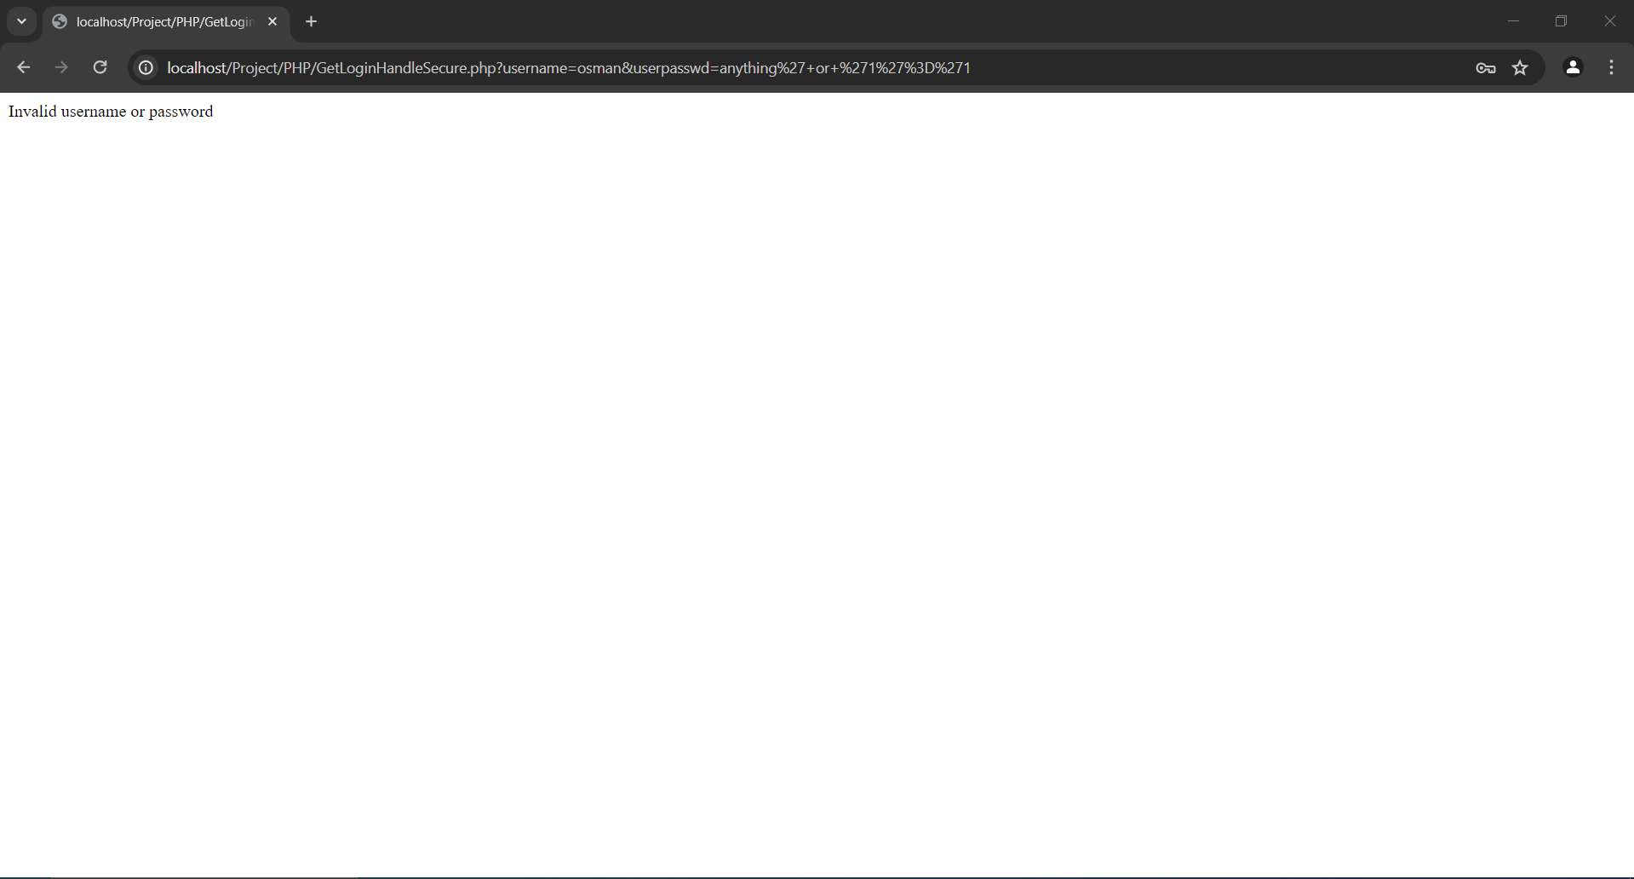

***Figure 37.*** SQL injection attempt failed

As we can see in Fig 38. as we can see in the secure version of the code we have implemented c statements which they force the user input to be sent to the backend as parameters instead of the user input becoming part of the SQL statement. so it creates a template statement that is then sent to the database with parameters that are left unspecified (the ? in the statement)

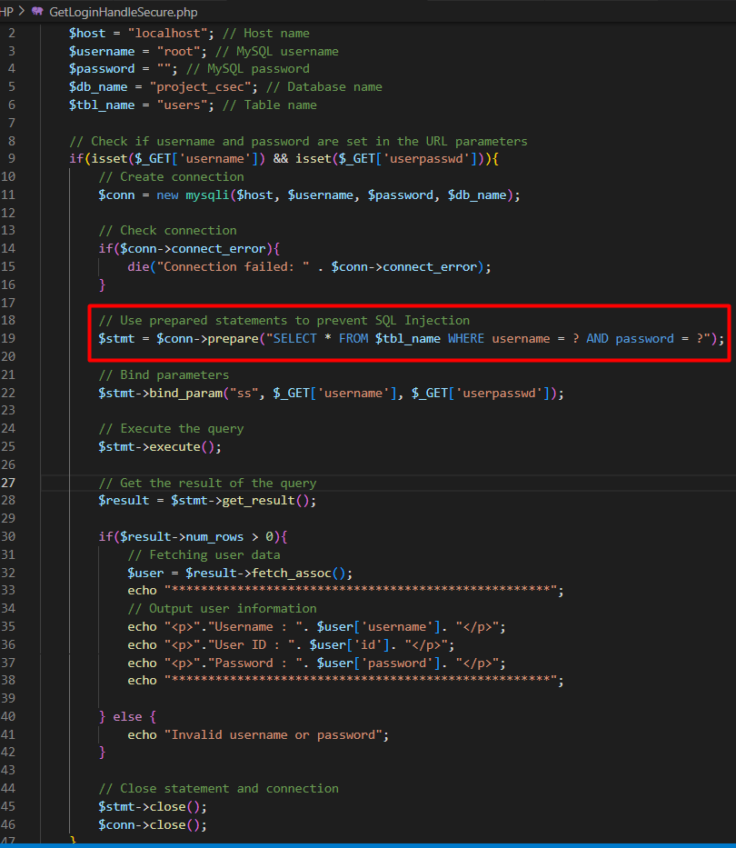

***Figure 38.*** The Secure code handling the login

## LFI

Local File Inclusion also known as LFI, this vulnerability allows the attackers to read or execute file on the server that is hosting the web application and this happens when a script includes a file based on the user input without properly sanitizing the input which can potentially allow the inclusion of files like configuration files, source code, or even executable scripts.

it's usually exploited by the attackers by manipulating the parameters that reference a file. Let's say for example, the attacker could modify a parameter in the URL to access critical system files such as /etc/passwd, or to execute harmful scripts that are stored on the server, effectively gaining unauthorized access to sensitive data or functionalities.

The impacts of LFI can be significant, including unauthorized disclosure of confidential data, server compromise, and execution of malicious scripts. This leads to some consequences such as data theft, system hijacking, or a full-scale breach of network security.

As we can see in Fig 39 . the insecure code shown below includes files directly based on the user input without validation, which makes it vulnerable to LFI for an attacker since they can manipulate the page parameter to include any file that is accessible by the server.

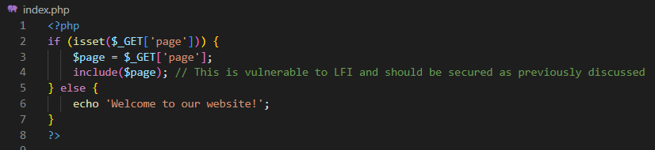

***Figure 39***. Insecure code of LFI

Now we will demonstrate the Secure version of the LFI. as we can see in Fig. that when we tried to include the file ( ?page=etc/password.txt ) but the website returned an error saying “Please select a valid page.” which means that the mitigation was successful for this attack.

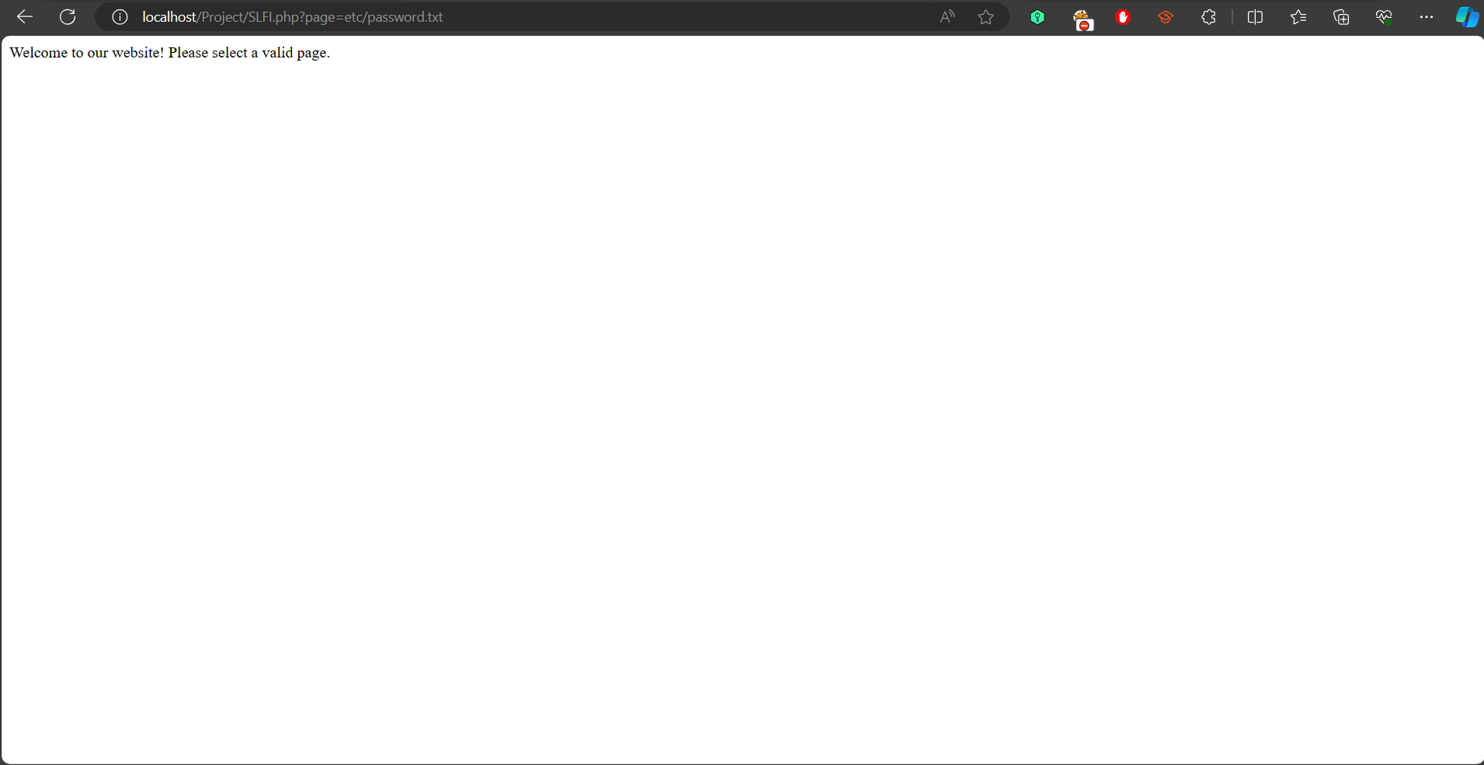

***Figure 40*** . Attempting to include the password file on The Secured version

The code shown in Fig 40. is the secure version of that code, here we went with the whitelist approach, where only file that are clearly mentioned in the allowedPages are allowed to be included. This will effectively prevent the attackers from including files that are not intended for public access.

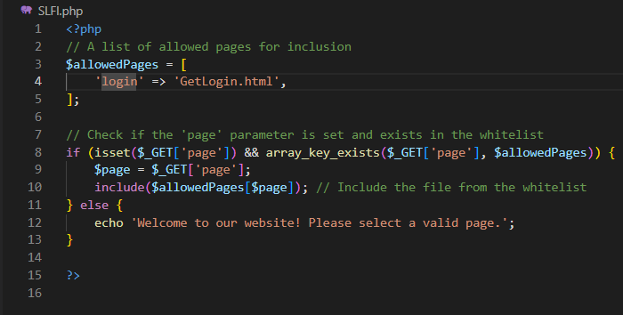

***Figure 41*** . The secure code of the LFI

Testing the Whitelist Approach. we will access the following url ( localhost/Project/SLFI.php?page=login). this page was included successfully as shown in Fig. because that PHP page was included in the whitelist that we created.

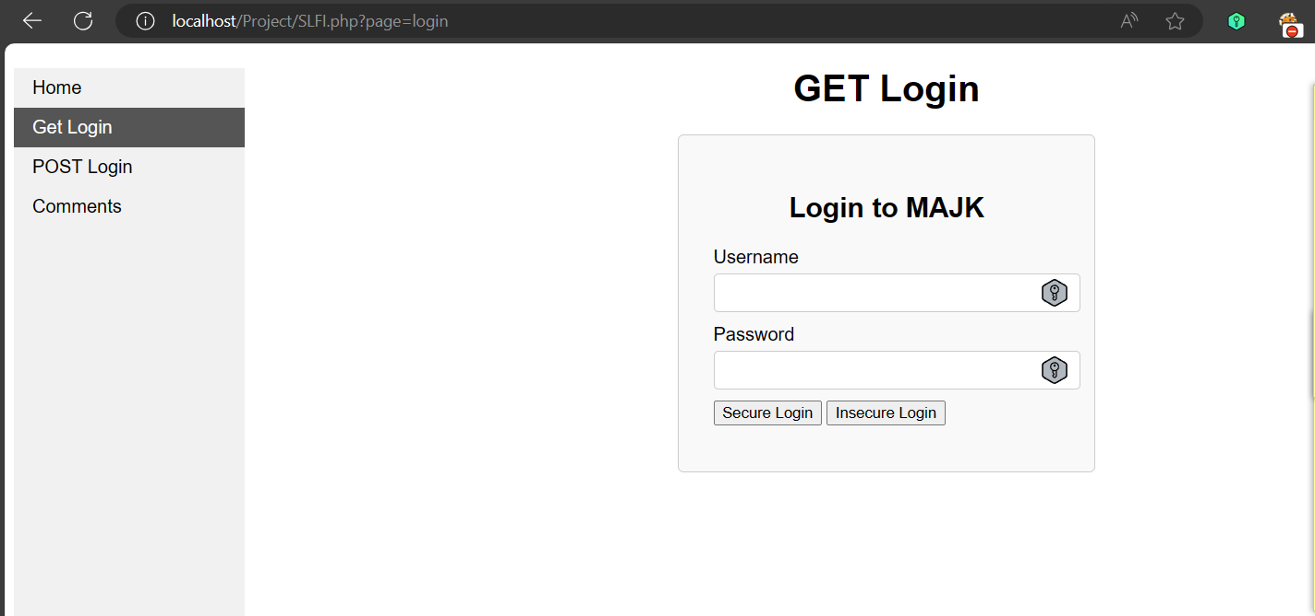

***Figure 42*** . Testing the whitelist implemented

## Brute Force Attack

The previously built website was vulnerable to the brute force attack script that we developed for attacking it. This is because the website did not have an account lockout feature, had weak password policies, transmitted credentials in an unsecured way, and did not implement limits on response times and attempts.

Now we must develop a way to prevent the brute force attack from attacking the vulnerable website that we previously built. The best mitigation approach to mitigating brute force attacks on the vulnerable website that was created previously is to apply rate limiting to the vulnerable website. Rate limiting means limiting the number of login attempts that can be made in a given time period, which makes it challenging to figure out valid passwords (Radware, 2024).

Figure 43 outlines the first implementation of a mitigation strategy for a brute force attack on a vulnerable website, which is rate-limiting. We must first navigate into the website's database using phpMyAdmin, click the "project_csec" MySQL database we created previously that contains the credentials of the users, and add a new table called "login_attempts" that stores the unique IDs, IP addresses, and timestamps of login attempts.

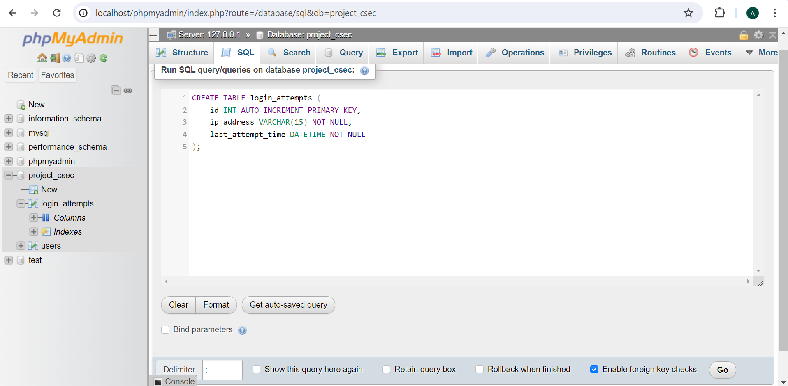

***Figure 43*.** Adding “login_attemps” Table in the Webstie’s MySQL Database

Figure 44 illustrates how we modified the "GETLoginHandle.php" file to implement mitigation for the brute force attack. The code starts by setting the maximum number of login attempts at two per hour and the duration of the lockout. After that, the code configures the system to track login attempts and potentially enforce lockouts by creating a database connection and retrieving user credentials from the URL parameters.

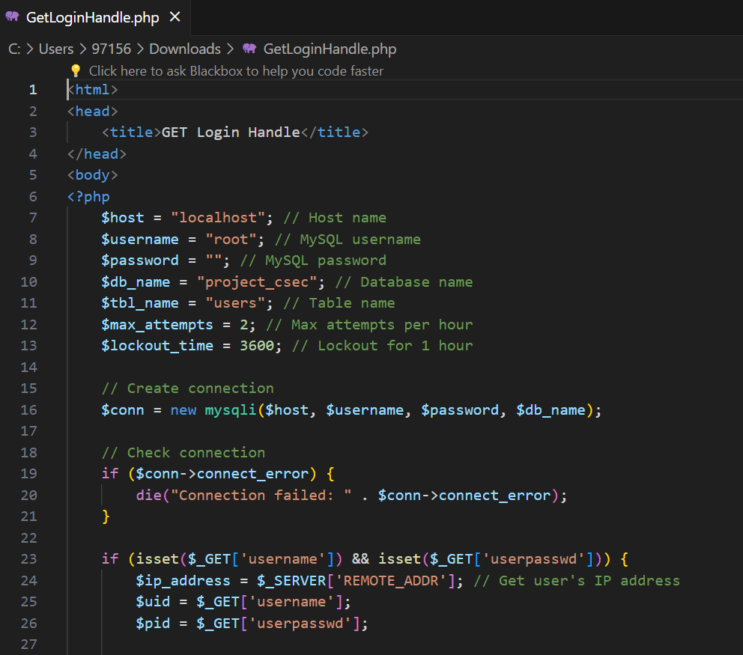

***Figure 44.*** Adding the Maximum Attempts Number and the Lockout Time in the Modified GETLoginHandle.php File

Figures 45 and 46 illustrate that the modified "GETHandleLogin.php" file determines whether the user's IP address has attempted more login attempts than is allowed in the recent hour and if not, it verifies the password and username entered. The user's information is displayed if the credentials are valid and if not, the unsuccessful attempt is recorded.

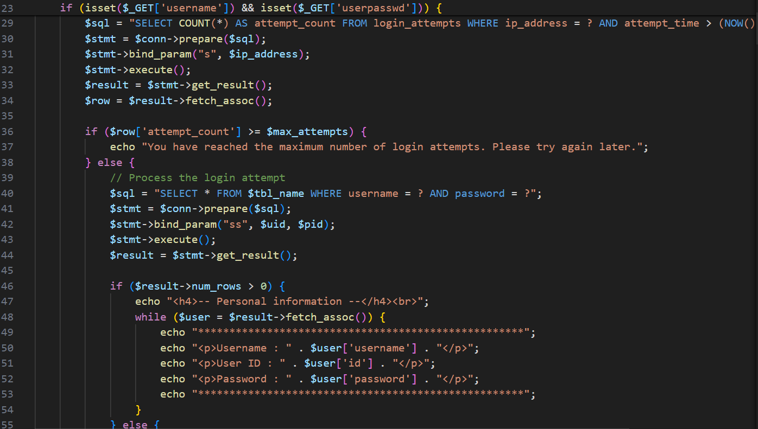

***Figure 45* .** Login Attempt Management and Authentication Handling in Modified GETLoginHandle.php File

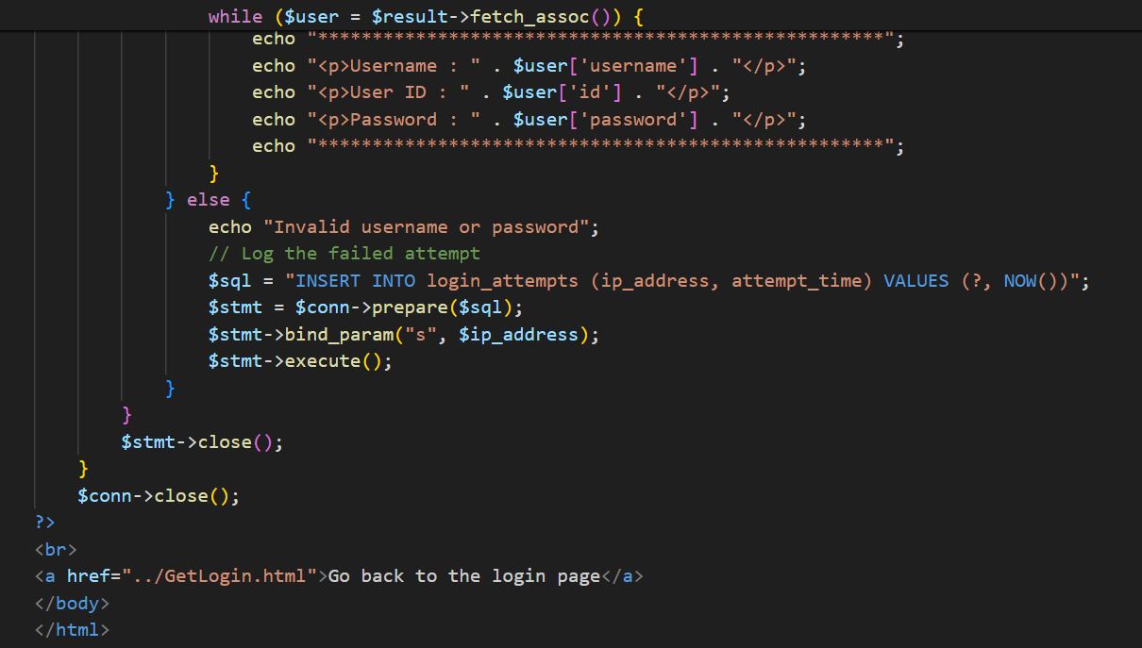

***Figure 46* .** ContinuationLogin Attempt Management and Authentication Handling in Modified GETLoginHandle.php File

Figure 47 shows visiting the GET login page website by right-clicking on "Inspect" and then select the console tab. Then copy and paste the brute force script into the console tab. Before running the script, we must enter the username on the GET login page. Assume that we already know the username "osman" and type it. The script will then be executed by pressing the enter key on the keyboard.

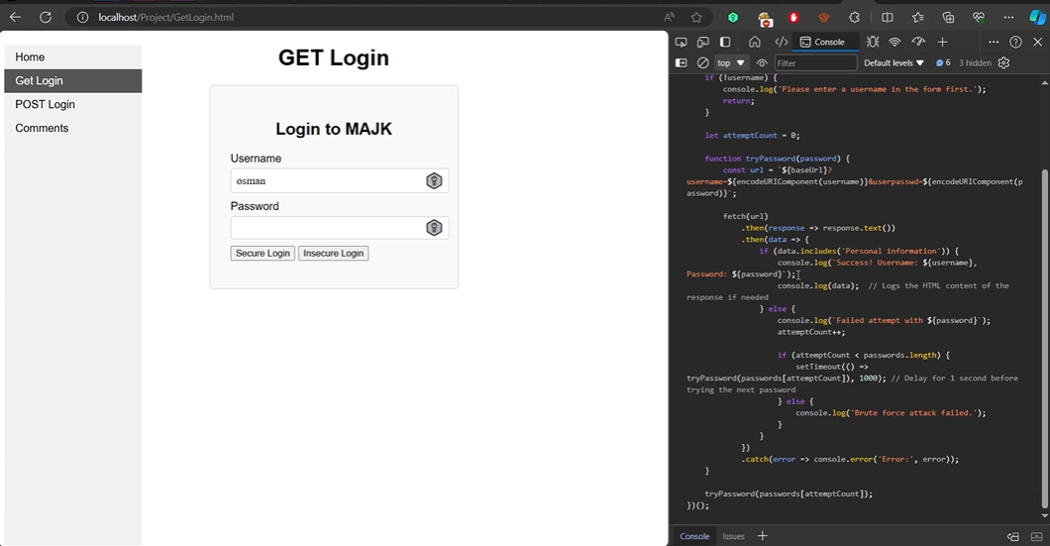

***Figure 47* .** Running the Brute Force Script in the Console Tab of the GET Login Page

Figures 48 and 49 indicate that after running the brute force script on the console tab of the GET Login webpage, it was unable to extract the password for the username "osman" due to the rate-limiting mitigation we implemented since it reached the maximum number of login attempts. This demonstrates that the mitigation technique we developed was successful and successfully evaded the brute force attack.

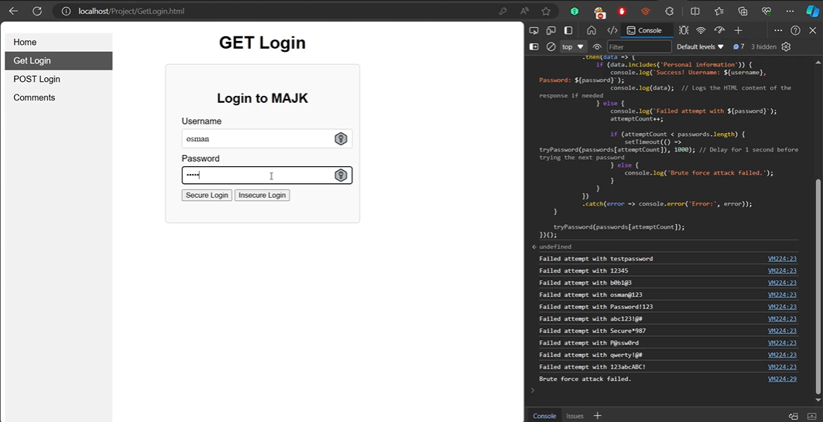

***Figure 48.*** Success of Rate-Limiting Mitigation Against Brute Force Attack

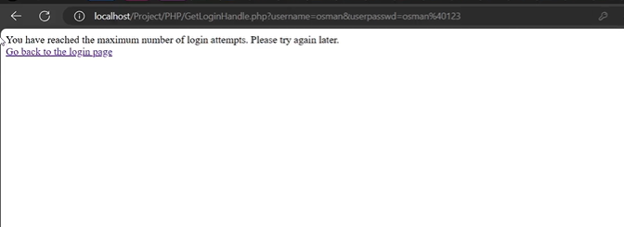

***Figure 49 .*** Maximum Login Attempt Limit Reached on the Profile Webpage

Figure 50 demonstrates that the phpMyAdmin page of the website's database on the "login_attempts" table that was recently created only allowed two maximum login attempts, both of which were unsuccessful, and could not allow more attempts because we only applied two maximum login attempts per hour on the modified "GETHandleLogin.php" code file.

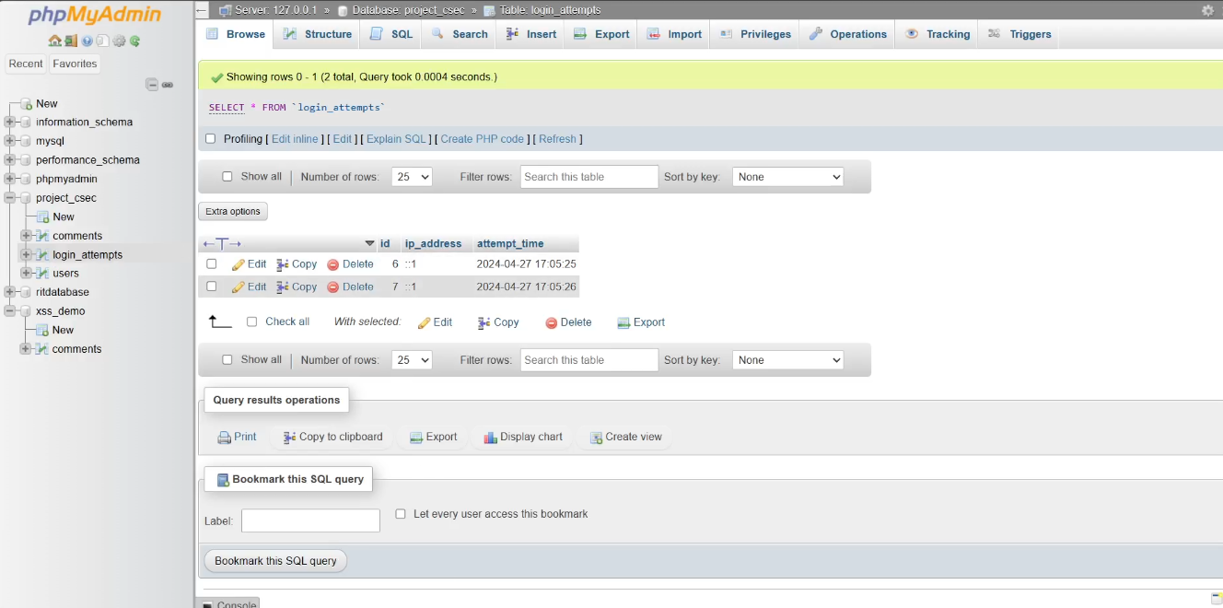

***Figure 50* .** Display of 'login_attempts' Table on the Database of the Website Showing the Enforcement of Two Maximum Login Attempts per Hour

## Insecure Direct Object Reference

Insecure Direct Object Reference (IDOR) attacks exploit fundamental security flaws, allowing attackers to bypass authentication and obtain unauthorized access to restricted resources. When performing IDOR, attackers can maliciously interact with websites and change a direct object reference, like filenames, database keys, or query parameters, in order to get private data or carry out actions that shouldn't be permitted (Kalos, 2023).

The vulnerabilities in our website that allow IDOR attacks to occur are primarily related to improper handling of user identification and authorization. We can strengthen the security of our website and reduce the risk of IDOR attacks by preventing unauthorized access to sensitive user data and making the following changes to our website:

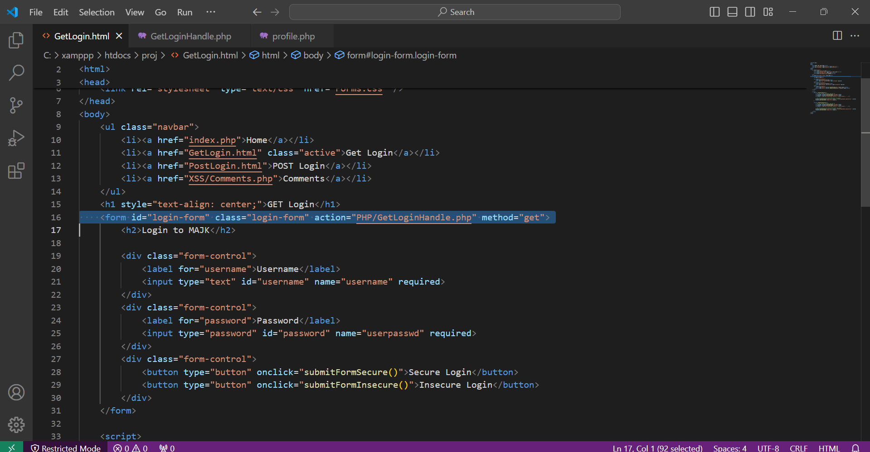

***Figure 51.***  Part of GetLogin.html mitigation code

In the code shown in figure 51 above, the form action attribute controls where the form data will be sent; it specifies the URL or script that will process the form input and perform the necessary actions, such as handling user authentication or data manipulation.

* **Form Tag:** The <form> tag defines an HTML form that allows users to input data, such as their username and password, for submission.
* **Action Attribute:** The action attribute specifies the URL or script that will handle the form submission. In this case, it is set to "login.php".
* **Method Attribute:** The method attribute specifies the HTTP method used to send form data to the server. In this case, it is set to "get", indicating that form data will be appended to the URL as query parameters when submitted.

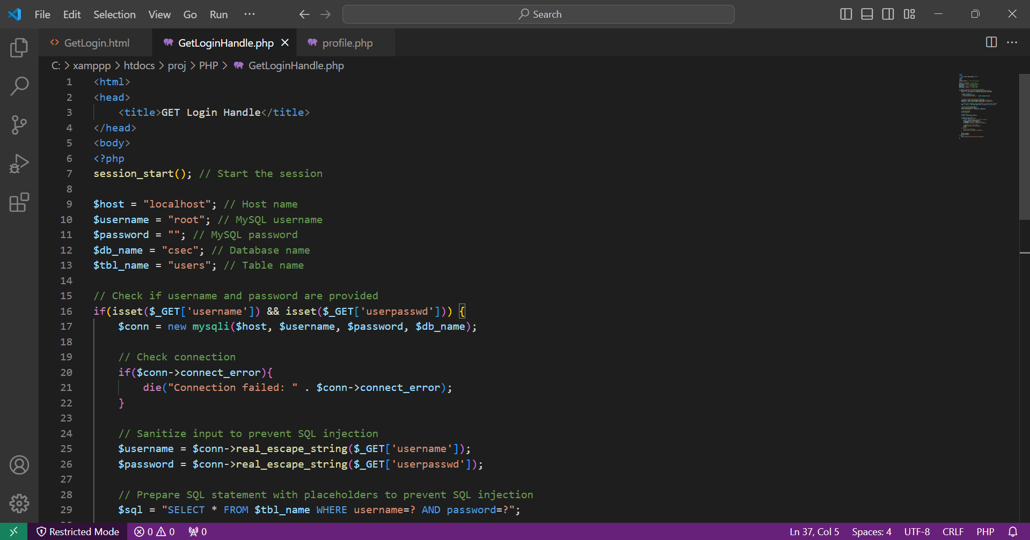

***Figure 52.***  Part of GetLoginHandle.php mitigation code

In the code shown in figure 52 above, we added a session management ‘session_start’ that starts a session to store user authentication information, and these sessions persist user data on multiple requests or pages which enhances security by storing the sensitive information on the server rather than exposing it to the client.

We also added input sanitization ‘real escape string’ to sanitize user input before incorporating it into SQL queries.

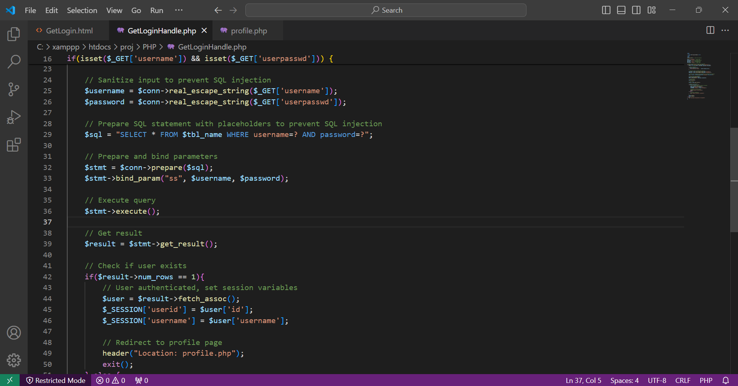

***Figure 53.***  Part of GetLoginHandle.php mitigation code

In addition, as shown in figure 53 above, we added session variables $_SESSION['userid'] where upon successful authentication, the user ID and username are saved in session variables ($_SESSION['userid'], $_SESSION['username']) and authenticated users can access protected resources without having to reauthenticate on every page, When a session is started, PHP generates a unique session ID for the client and sends it as a cookie. This session ID allows the server to associate subsequent requests from the same user with their session data. We also added a redirection header “Location: profile.php”, where after successful login, authenticated users are redirected to the profile.php page using the header() function.

In figure 52 and 53 above, we added a session management ‘session start’, which starts the session to get user authentication information. After that, we added a session variable $_SESSION['userid'] to get the user ID from the session to make sure that only authenticated users have access to the profile page. We also added a redirection header “location: login.php”, that redirects users to the login page if they are not logged in to make sure that unauthorized users do not have access.

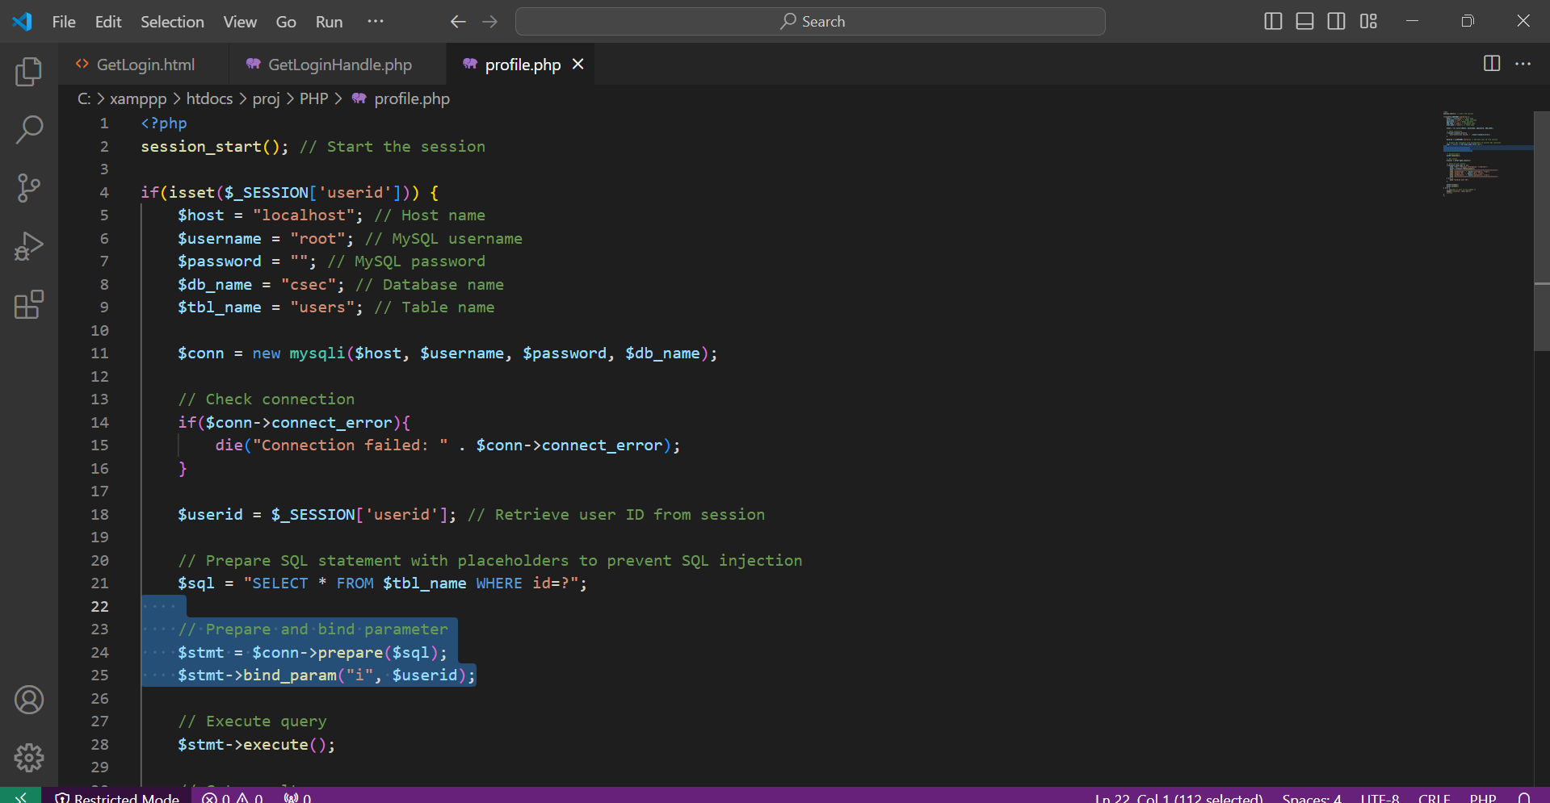

***Figure 54a.***  Part of profile.php mitigation code

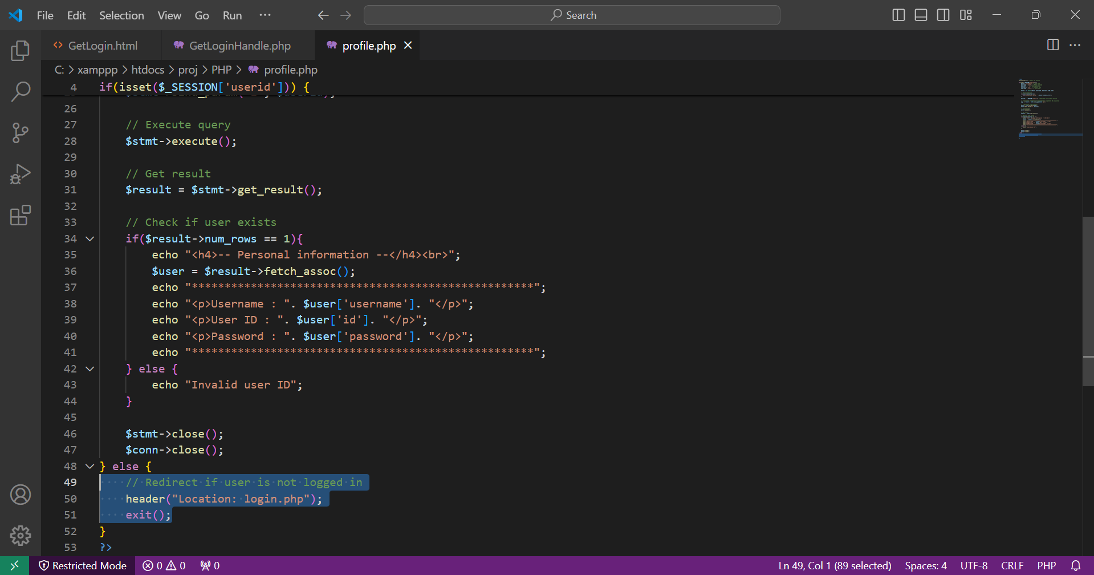

***Figure 54b.***  Part of profile.php mitigation code

In figure 54a and 54b above, we added a session management ‘session start’, which starts the session to get user authentication information. After that, we added a session variable $_SESSION['userid'] to get the user ID from the session to make sure that only authenticated users have access to the profile page. We also added a redirection header “location: login.php”, that redirects users to the login page if they are not logged in to make sure that unauthorized users do not have access.

The user will no longer be able to view any sensitive data on the URL when they attempt to log in normally using their credentials; instead, they will only be able to view their personal information. As a result, the attacker cannot alter the URL parameter or conduct an IDOR attack using the user's input, as seen in the figure below.

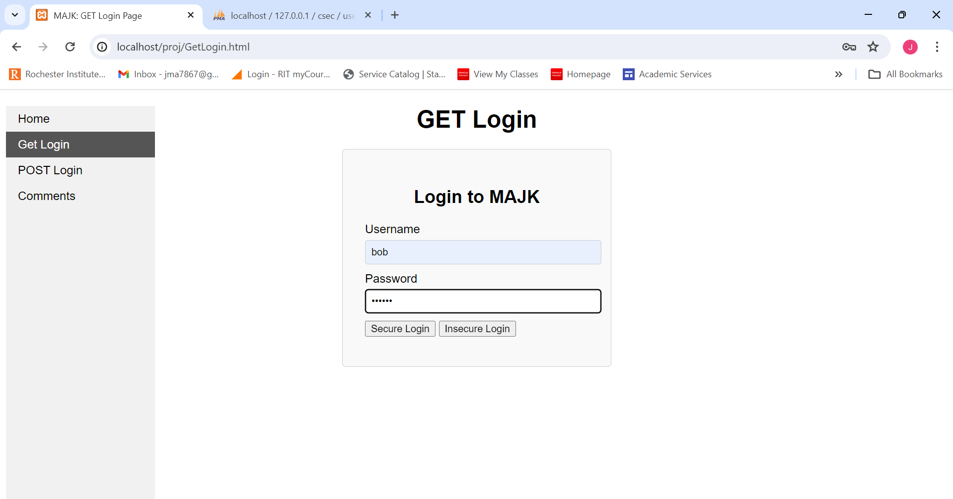

***Figure 55a.***  User login page

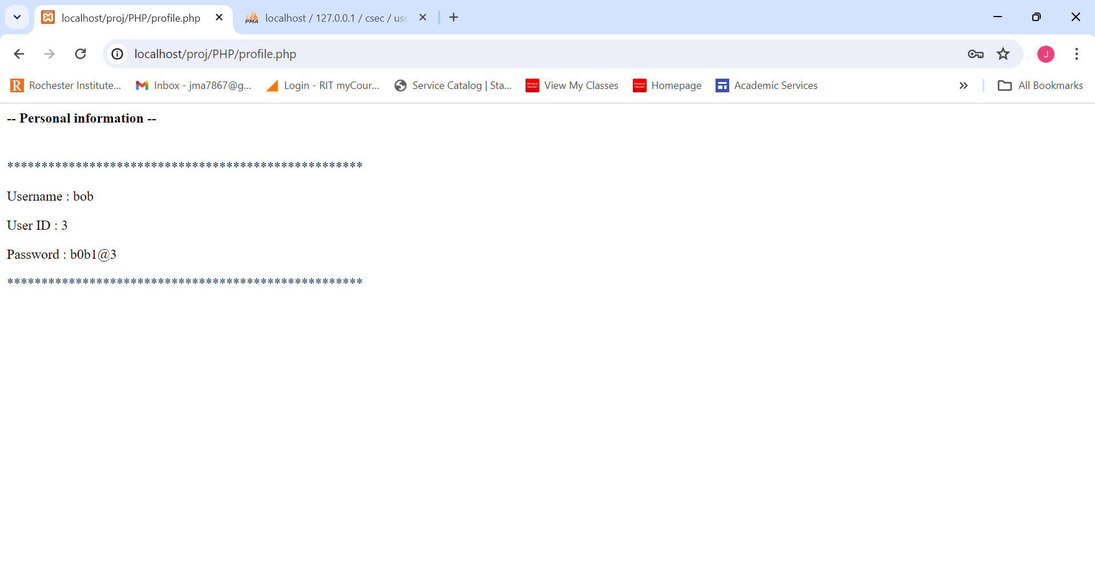

***Figure 55b.***  User personal information page

# Problems Faced

We didn't encounter a lot of problems when working on the project because the instructions and their implementation were simple and straightforward. We did, however, run into a small problem where the XAMMP program was not running properly, it could not run the localhost on Google Chrome as intended and couldn’t fetch the websites that we had created so I had to use my colleague’s PC in order to use their XAMPP program and start implementing my part of the project.

# Conclusion

In conclusion, we learned in this project that any website is vulnerable to many attacks. The main attacks that could be performed are persistent XSS, SQL injection attacks, LFI attacks, brute-force attacks, and insecure direct object references (IDOR). These attacks could be performed either by an intelligent attacker who exploits small vulnerabilities in the website or because of the mistakes that the developer of the website makes. In this report, we explained both how the attacker could perform these attacks by exploiting the developer’s mistakes, the vulnerabilities that made the attacks successful, and how we, as developers, can mitigate these attacks and vulnerabilities by implementing some important functions. The mitigation methods that we have implemented for each attack are rate limiting for brute force attacks, the usage of prepared statements for SQL injection attacks, the use of the function “htmlspecialchars” to escape special HTML characters from the user input before displaying them on the webpage for persistent XSS attack, the use of the whitelist approach, where only file that is clearly mentioned in the whitelist are allowed to be included for the LFI attack, and we implemented session management and added a redirection mechanism to restrict access to authenticated users for insecure direct object references (IDOR) attacks.

# References

OWASP Foundation. (2024). *Testing for Insecure Direct Object References*. WSTG - Latest. https://owasp.org/www-project-web-security-testing-guide/latest/4-Web_Application_Security_Testing/05-Authorization_Testing/04-Testing_for_Insecure_Direct_Object_References

Radware. (2024, January 13). *What is rate limiting and how does it work?* https://www.radware.com/cyberpedia/bot-management/rate-limiting/#:~:text=Rate%20limiting%20can%20help%20to%20prevent%20brute%20force%20attacks%20by,attackers%20to%20guess%20valid%20credentials.

Tam, K. (2023, March 20). *What is a brute force attack?: Definition, Types & How It Works*. Fortinet. https://www.fortinet.com/resources/cyberglossary/brute-force-attack